The Handbook of Fixed Income Securities
Notes by Day Yi
Chapter 58:

Interest Rate Caps and Floors and Compound Options
- INTRODUCTION
  - Interest-rate caps allow the purchaser to cap the contractual rate associated with a liability
  - Interest-rate floors allow the purchaser to protect the total rate of return of an asset
  - The protection provided by caps and floors is asymmetric, in that the purchaser is protected from adverse moves in the market but maintains the advantage of beneficial moves in market rates
- FEATURES OF INTEREST-RATE CAPS AND FLOORS
  - The underlying index from which the contractual payments will be determined can be chosen from a set of indexes based on
    - LIBOR
    - Commercial paper
    - Prime rate
    - Treasury bills
    - Certificates of deposit
  - The strike rate is the rate at which the cash flows will be exchanged between the purchaser and seller of the customized interest-rate protection instrument
  - The term of the protection may range from several months to about 30 years, although the liquidity of longer dated caps is not sufficiently high
  - The settlement frequency refers to the frequency with which the strike rate will be compared to the underlying index to determine the periodic contractual rate for the interest-rate protection agreement
  - The notional amount of the agreement on which the cash flows are exchanged is usually fixed, unless the terms of the agreement call for the amortization of the notional amount
    - For instance, in “spread enhancement” strategies, which involve the purchase of an amortizing asset, such as a fixed-rate mortgage-backed security funded by floating-rate capped liabilities, amortization of the cap notional amount may be necessary in order to maintain the spread
- PRICING OF CAPS AND FLOORS
  - The up front premium is the fee paid by the purchaser to the seller of the interest-rate agreement at the inception of the contract
    - Determined by factors such as
      - The strike rate
      - Volatility of the underlying index
      - The length of the agreement
      - The notional amount
      - Any special features, such as amortization of the notional principal
  - The pricing of both caps and floors draws heavily on option pricing theory
    - An increase in market volatility results in a higher premium for both the cap and the floor
    - The strike rate
      - For a cap is inversely related to the premium paid for the cap because rates have to advance before the cap is in the money
      - For a floor is directly related to the up-front premium
    - The longer the term-to-maturity, the greater the premium because optional protection is available for a longer period of time
    - The agreement with a shorter payment frequency will command a higher premium because there is a greater likelihood of payoff and the payments are determined only on the settlement date
    - There also may be additional contractual features, such as
      - Variable premiums
      - Cost of termination options prior to stated maturity
      - Conversion privileges from one program to another
      - Purchase of a combination of programs, such as interest-rate collars and corridors
- INTEREST-RATE CAPS
  - An interest-rate cap can be used to create an upper limit on the cost of floating-rate liabilities
  - If the market rate exceeds the strike rate of the cap on the settlement date, the seller of the cap pays the difference
  - Cap payments are computed as follows

(Index rate — Strike rate) x (Days in settlement period / 360) x Notional amount

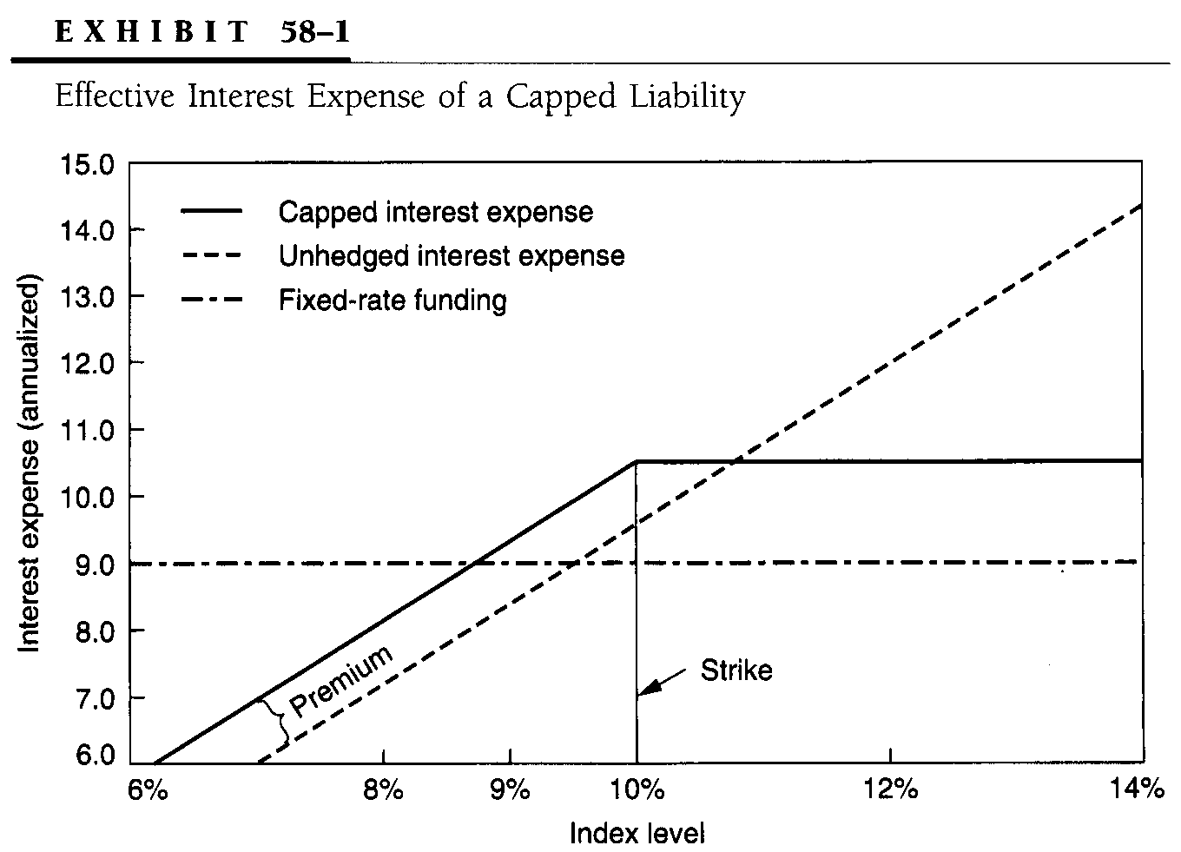
  - Because the purchaser of the cap benefits in rising rate scenarios, the conceptual options analog is a strip of put options
  - There are several advantages associated with the use of the cap in protecting the interest expense of a floating-rate liability
    - The purchaser of the cap can obtain protection against higher rates and also fund the liabilities at a floating rate to take advantage of lower interest rates
      - In this respect, the capped liability strategy can result in a lower cost of funds than certain fixed-rate alternatives
    - Caps can also be used to synthetically strip embedded caps in floating-rate instruments such as CMO floaters and adjustable-rate mortgages
- PARTICIPATING CAPS
  - A common theme in the definition of such instruments is the absence of an up-front fee used to purchase the cap
    - One type of participating cap involves the purchase of cap protection where the buyer obtains full protection in the event that interest rates rise
    - In order to compensate the seller of the cap for this bearish protection, the buyer shares a percentage (the participation) of the difference between the capped rate and the level of the floating-rate index in the event that interest rates fall

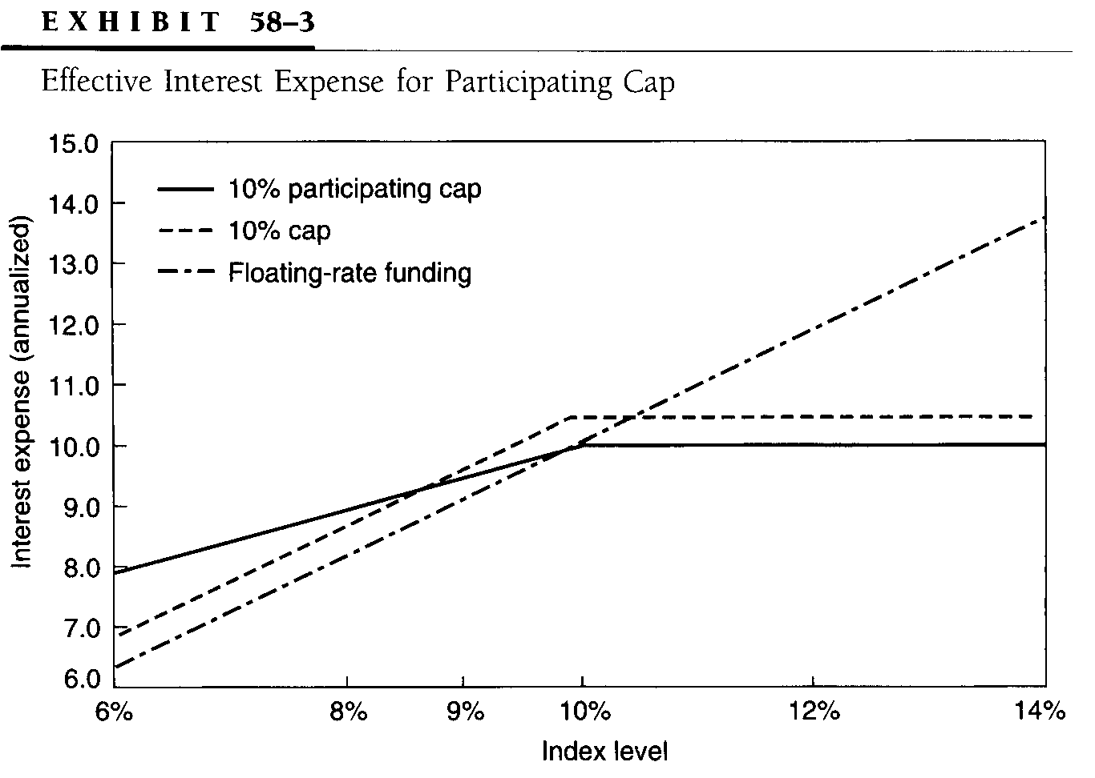
  - Other participating instruments, also known as participating swaps, combine the analytical elements of interest-rate swaps and caps to create a hedge for floating-rate liability costs
    - In a participating cap structure, the firm uses
      - Interest-rate swaps to convert the floating liability rate to a fixed rate
      - Caps to create a maximum upper limit on the remainder of the interest expense of the floating-rate liability
    - However, what distinguishes this structure is that the caps are purchased without paying an up-front fee
      - The purchase is funded by executing the swap (fixed-rate payer/floating-rate receiver) at an off-market rate involving a higher spread than the current market rate for equivalent maturity swaps

(PV of annuity at r₀ – r_{m}, t) x (% of swap) = Cap Premium x (% of cap)

where r_{m} = Current market swap fixed rate for t periods

r₀ = Off-market swap fixed rate for t periods

% of swap + % of cap = 1
- INTEREST-RATE FLOORS
  - Interest-rate floors are used to protect the overall rate of return associated with a floating-rate asset

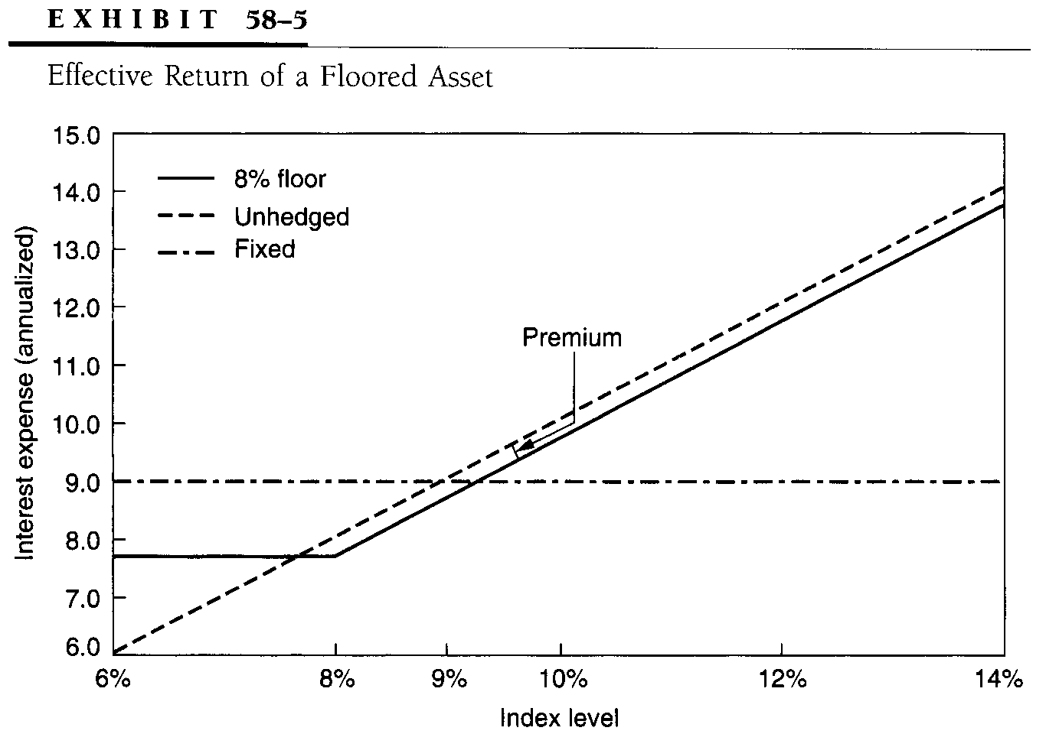
  - A floor is beneficial in bullish interest-rate scenarios
    - Hence, purchasing a floor is analogous to buying a strip of call options
- INTEREST-RATE COLLARS
  - Interest-rate collars involve
    - The purchase of a cap to hedge a floating-rate liability at a higher strike rate
    - The sale of a floor at a lower strike rate to offset the cost of purchasing the cap
  - Three scenarios at the reference date
    - If the underlying index rate exceeds the capped rate on the reference date, the seller of the cap pays the firm the amount above the capped rate
    - If the market rate is less than the floor strike rate, the firm pays the buyer the difference between the floor rate and the index level
    - If the market rate is between the strike rate of the cap and the strike rate of the floor, the effective interest costs of the firm are
      - Normal floating-rate funding costs plus
      - The amortized cap premium (outflow) less
      - The amortized floor premium (inflow)
  - The net effect of this strategy is to limit the coupon rate of the floating-rate liability between the floor strike rate and the cap strike rate
  - The coupon liability rate is adjusted by the net amount of the amortized cap premium paid and the amortized floor premium received to determine the effective interest cost

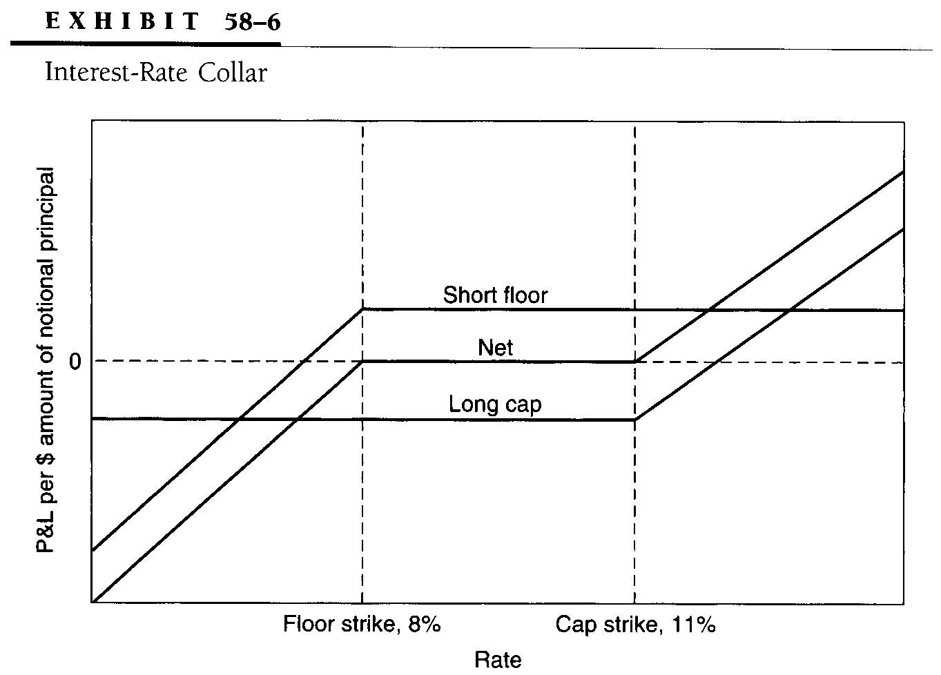
  - The main benefit from an interest-rate collar is that the firm obtains protection from interest-rate increases at a considerably lower cost than with the purchase of a cap
    - In return for the benefit of lower-cost interest-rate protection, the firm gives up the benefit from market rallies below the floor strike rate
    - Because the interest-rate protection is obtained without fixing rates, interest-rate collars are sometimes also described as swapping into a bond
- INTEREST-RATE CORRIDORS
  - An alternative strategy to reduce the cost of the cap premium is to buy a cap at a particular strike rate and sell a cap at a higher strike rate, reducing the cost of the lower strike cap and hedging the interest expense of a floating-rate liability
    - In contrast to an interest-rate collar, the firm maintains all the benefit of falling interest rates, because there is no sale of a floor
    - As long as rates are below the strike rate of the lower strike cap, the effective interest expense of the firm is limited to normal borrowing cost plus the amortized net cap premium
    - As interest rates increase above the lower strike rate, the interest cost to the firm is capped until market rates are above the higher strike cap
    - As interest rates rise above the strike rate of the second cap, interest costs increase by the amount of the outflow of the cap

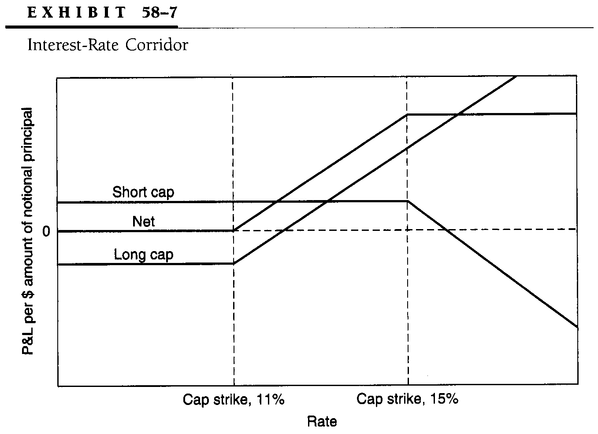
- CAP/FLOOR PARITY
  - The cap/floor swap parity may be stated as

Long cap + Short floor = Fixed swap
  - However, for cap/floor swap parity to hold, the fixed rate of the swap should be paid on the same basis (actual/360 days, 30/360 days, or actual/365 days) as the floating rate, not a varying basis on the two rates

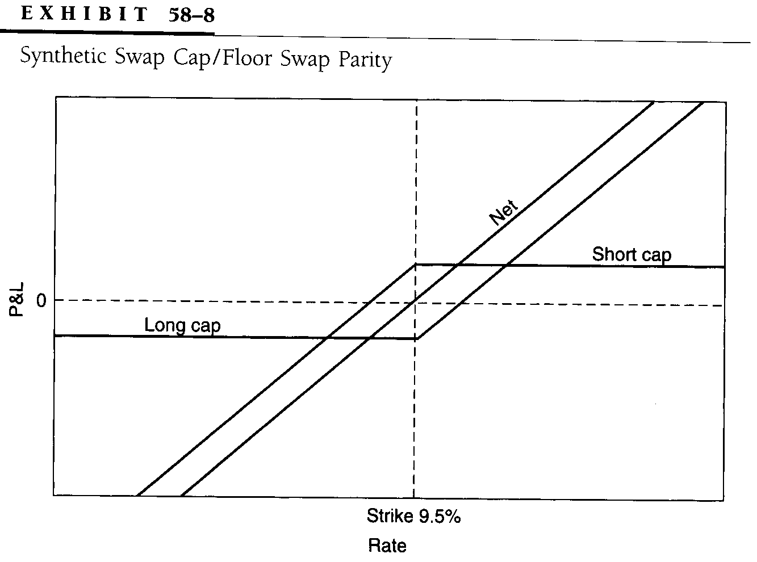
  - The cost of a market swap is zero because no premium cash flows are exchanged at inception
    - Using cap/floor swap parity, the cost of a cap should be the same as the cost of a floor struck at the same rate on an identical index
    - Unless this relationship is true at every point, an arbitrage exists in these markets that could be used to emulate the characteristics of the overpriced instrument
- TERMINATION OF CAPS AND FLOORS
  - As is apparent from the discussion on the characteristics of caps (floors), these instruments are essentially a strip of put (call) options on forward interest rates
  - The termination value of caps and floors can be determined using concepts similar to those involved in determining the market value of options (premium) prior to expiration
- COMPOUND OPTIONS
  - Interest-rate protection provided by conventional options, such as puts and calls, and derivative option-like instruments, such as caps and floors, extends over a specified period of time
  - For a shorter time horizon where the holding (outstanding) period of the asset (liability) is subject to change, firms can use interest-rate debt options
    - Such options can be used to manage asset/liability spreads or offset short-term opportunity losses associated with long-term interest-rate protection instruments
    - In recent years, an important innovation known as compound options or split-fee options has allowed investors to limit losses of such short-term option strategies by permitting them to assess market conditions before purchasing additional optional coverage
  - Compound options, which are essentially options on options, allow the firm to purchase a window on the market by paying a premium that is less than the premium on a conventional option on the same underlying instrument
    - The optional coverage can be extended at expiration of the window period by paying another premium
    - In essence, compound options provide an additional element of risk management by providing the opportunity to further limit downside losses associated with asymmetric coverage without sacrificing the essential ingredients of optional coverage
  - Compound options allow the investor to purchase an option to exercise another option by paying a fee known as the up front premium for a specified period of time
    - At the end of this period, known as the window date, the investor may exercise the option on the option by paying another fee known as the back-end fee
    - Split-fee options also have been labeled up and on options
  - Comparison with Conventional Option Strategies
    - Compound options offer several advantages over conventional options, such as
      - Additional leverage and greater risk-management capabilities
    - With the compound put option, the same degree of protection afforded by the conventional put is available in bullish interest-rate scenarios at a much lower cost
  - Uses of Compound Options
    - Compound options have been used mainly to hedge mortgage pipeline risk, especially the risk of applicants seeking alternative sources of financing or canceling the loan
      - This risk, known as fallout risk, is usually hedged by purchasing put options
      - With a compound put option, the mortgage lender can obtain the same optional protection at a much lower cost and retain the flexibility of extending the protection after assessing market conditions
    - Portfolios using active call-buying programs as yield-enhancement vehicles may purchase compound calls when there is uncertainty regarding an impending fall in interest rates
      - Instead of purchasing a higher-premium conventional call, the compound call allows the portfolio manager to purchase a window on the market for a lower cost
    - Compound options, such as calls, can also be used in conjunction with longer-term instruments, such as fixed interest-rate swaps, to offset short-term opportunity losses caused by a fall in interest rates
      - However, perhaps the largest potential use of compound option technology lies in the application of these concepts to the cap and floor market in designing long-term options on options
      - Recall that caps (floors) are essentially a package of European puts (calls) on forward interest rates
      - The market for options on caps and floors, which allow the buyer to either cancel or initiate customized interest-rate protection, is still fairly undeveloped, but the potential uses of such instruments are enormous
      - As with any optional coverage, the development of such options on a series of options will add another element of flexibility provided by customized risk-management instruments

