The Handbook of Fixed Income Securities
Notes by Day Yi
Chapter 39:

Bond Management: Past, Current, and Future
- TRADITIONAL FIXED INCOME PORTFOLIO STRATEGY
  - The primary functional areas of modem fixed income management are shown in Exhibit 39—1

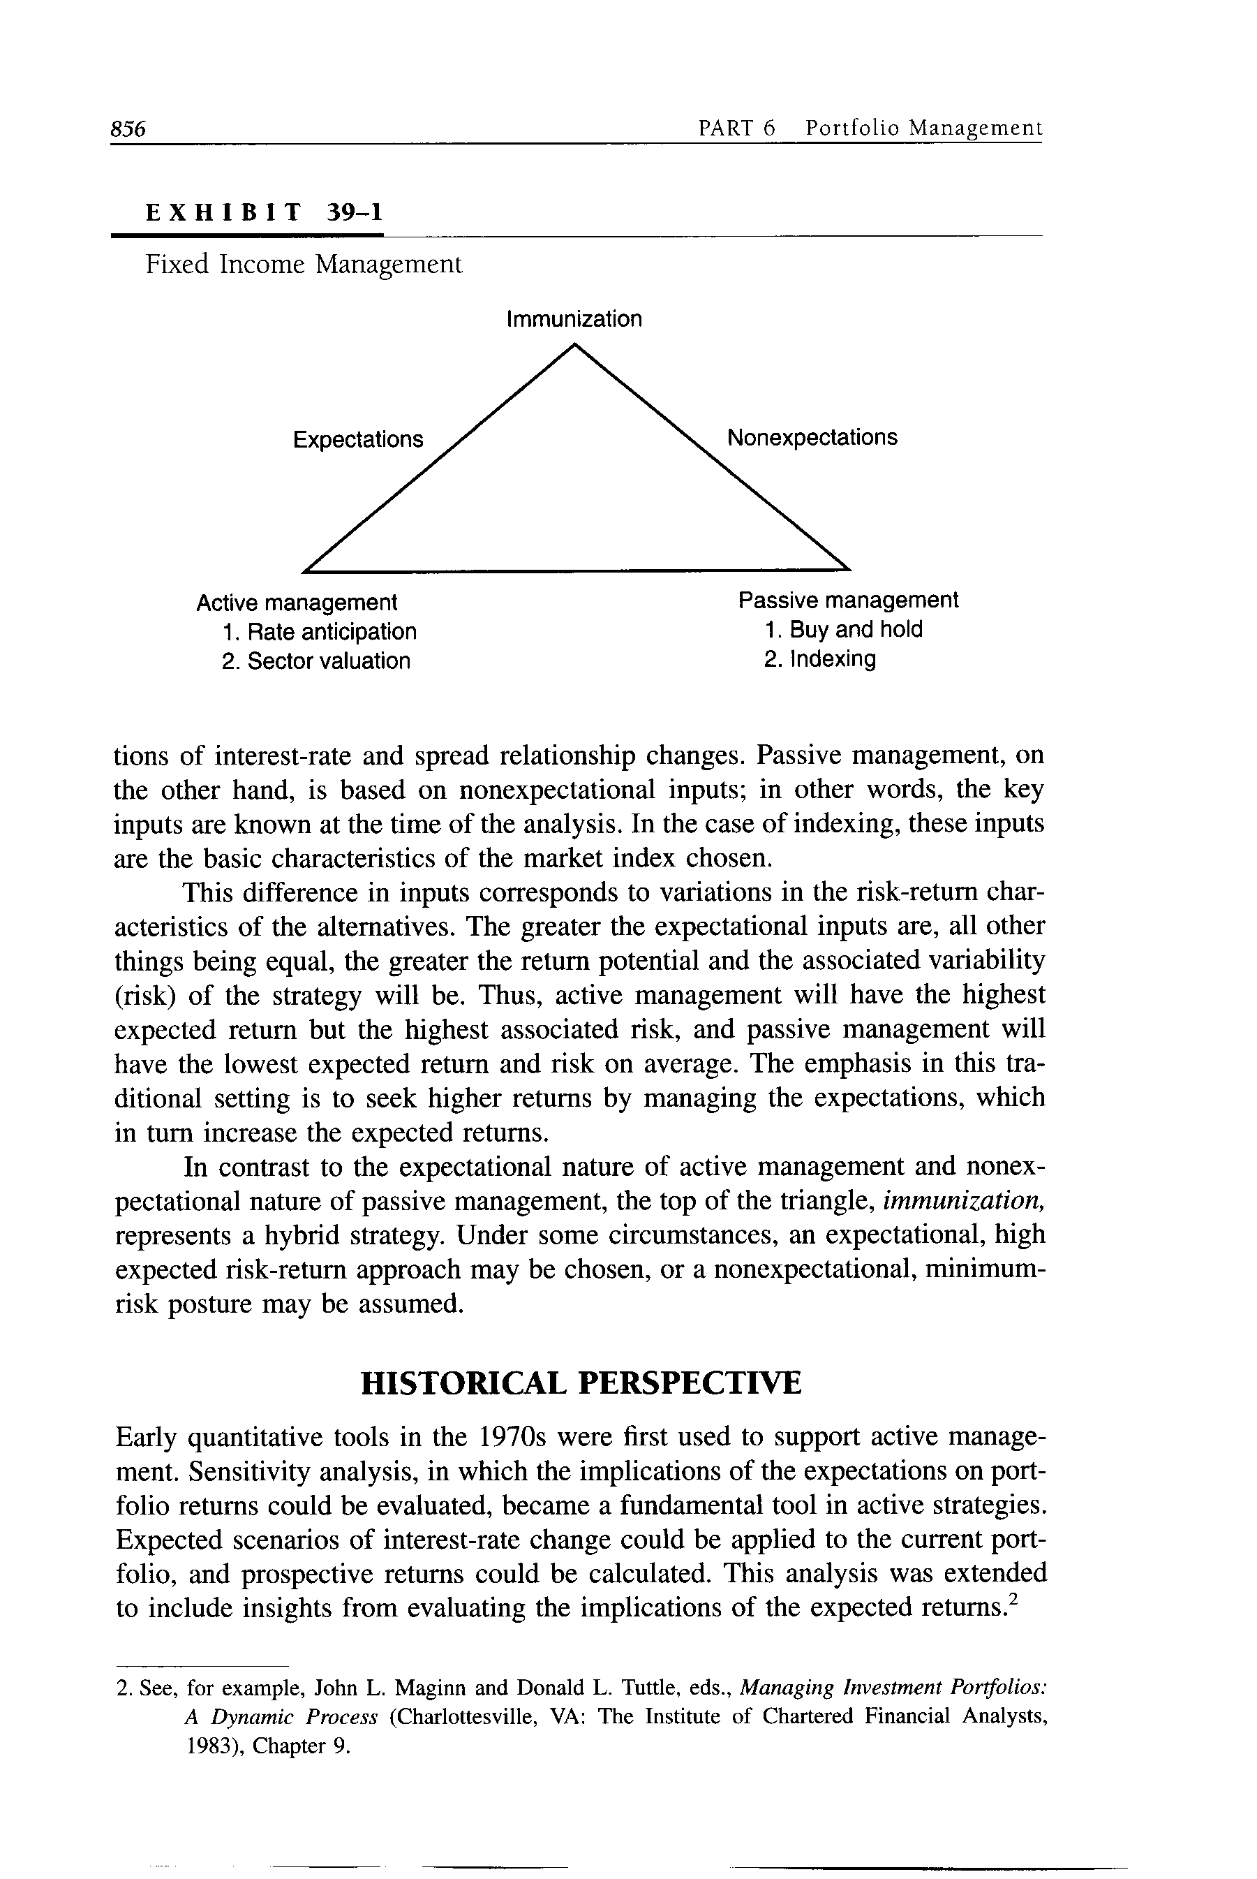
    - Active management
      - Rate anticipation
      - Sector management
      - Key to this area are expectations of interest-rate change and/or sector spread (yield difference from Treasury securities)
    - Passive management
      - Buy-and-hold strategy
      - Indexing to a representative market bogey
  - Active and passive management can be differentiated on the basis of the kinds of input necessary
    - Traditional active management is “expectationally driven”
      - The most important set of inputs will be expectations of interest-rate and spread relationship changes
    - Passive management is based on nonexpectational inputs
      - The key inputs are known at the time of the analysis
      - In the case of indexing, these inputs are the basic characteristics of the market index chosen
  - This difference in inputs corresponds to variations in the risk-return characteristics of the alternatives
    - The greater the expectational inputs are, all other things being equal, the greater the return potential and the associated variability (risk) of the strategy will be
    - Active management will have the highest expected return but the highest associated risk, and passive management will have the lowest expected return and risk on average
    - The emphasis in this traditional setting is to seek higher returns by managing the expectations, which in turn increase the expected returns
  - In contrast to the expectational nature of active management and nonexpectational nature of passive management, the top of the triangle, immunization, represents a hybrid strategy
- HISTORICAL PERSPECTIVE
  - Early quantitative tools in the 1970s were first used to support active management
    - Sensitivity analysis, in which the implications of the expectations on portfolio returns could be evaluated, became a fundamental tool in active strategies
    - Expected scenarios of interest-rate change could be applied to the current portfolio, and prospective returns could be calculated
  - This early application represents the quantification of a traditional task that was formerly done informally by the portfolio manager
    - With this tool, the portfolio manager could pursue a more systematic and structured approach to portfolio decision making
    - This was not merely a foreign step, but rather an alternative path freeing the time of the portfolio manager
    - Given the usual demands on the available time of the portfolio manager, this quantitative assistance leveraged the ability of the manager to focus on the expectational inputs that are central to the active management process
  - With the approach of the 1980s, new developments encouraged the use of an old concept in a new form — immunization
    - When relatively high interest rates prevailed (in relation to the typical actuarial assumption), and the desire to minimize pension contributions and the growth of new theoretical understanding emerged at the same time, the basis for the use of immunization was laid
    - The tarnished reputation of traditional active management (due to the performance of many portfolio managers in the 1970s) further confirmed the need for a new strategy
  - In the 1980s, the further evolution of strategy took the direction of duration-controlled approaches
    - Given the aversion to unexpected exposure to changes in interest rates, reliance on interest-rate risk control by monitoring the duration of the portfolio became widespread
    - Out of this trend emerged indexing, which targeted the portfolio duration
    - Indexing is extremely quantified and minimizes the need for expectational input
  - More recently, other targeted-duration strategies have emerged
    - These, in general, have a duration target different from the popularly followed bond indexes but serve a similar function: limiting or controlling the exposure to interest-rate changes by “targeting” the duration
- QUANTITATIVE INNOVATION
  - More recent developments, such as indexing and immunization, suggest that quantitative innovation supplemented by traditional activities such as investment objective setting and trading can be the principal expedient of portfolio management
  - Of the important contributing factors to the return of a fixed income portfolio
    - Duration management has had the greatest impact followed by
    - Sector selection and then
    - Individual bond selection
  - Targeted-duration strategies are designed to preclude large return departures from the chosen duration level
  - Drawn from modern option valuation theory, an asset allocation analysis can provide a form of active duration management
    - The objective is to create a synthetic call option on the best performing of the two extremes of the selected duration range
  - Consider the management of an intermediate fixed income portfolio made up of high-grade government and corporate securities
    - Conventional indexing would target the duration of the index as the duration of the portfolio to be held
    - Value enhancement would take the form of a sector selection and/or individual security selection
    - Return differences from the most important management activity, that of active duration management, would be eliminated
  - Introducing active duration management using option valuation technology can retain the most important source of management return, without the need for interest-rate forecasting
    - The portfolio returns would be further enhanced by using a term-structure model to value Treasury securities and a bond valuation model for the balance of the portfolio
    - By harnessing the quantitative innovation of option valuation technology, active duration management without the need for interest-rate forecasting is made possible
  - Another nonexpectational form of active duration management is tactical asset allocation
    - This strategy varies the duration of the portfolio based on fair value for the bond market
    - When the market is considered undervalued, the duration of the portfolio will be lengthened to what is considered normal
    - When the market is considered overvalued, the portfolio duration is shortened
    - The key is the determination of what is “fair value”
      - Tactical asset allocation differs from an option valuation approach
        - Expectations are required in the determination of fair value for tactical asset allocation
        - The option valuation approach does not rely upon asset valuation expectation

