The Handbook of Fixed Income Securities
Notes by Day Yi
Chapter 34:

Valuation of Bonds with Embedded Options
- IMPLICATIONS OF CALLABLE BONDS
  - The holder of a callable bond has given the issuer the right to redeem the bond before its maturity date
  - The call option poses two related disadvantages to the holder
    - It exposes the investor to reinvestment risk of principal because the issuer will call only when the current market rate is less than the coupon
    - The price appreciation potential for a callable bond is restricted
- COMPONENTS OF BONDS WITH EMBEDDED OPTIONS
  - In effect, the holder of a callable bond has bought an optionless or option-free bond and has sold a call option

Callable bond value = Optionless bond value — Call option value

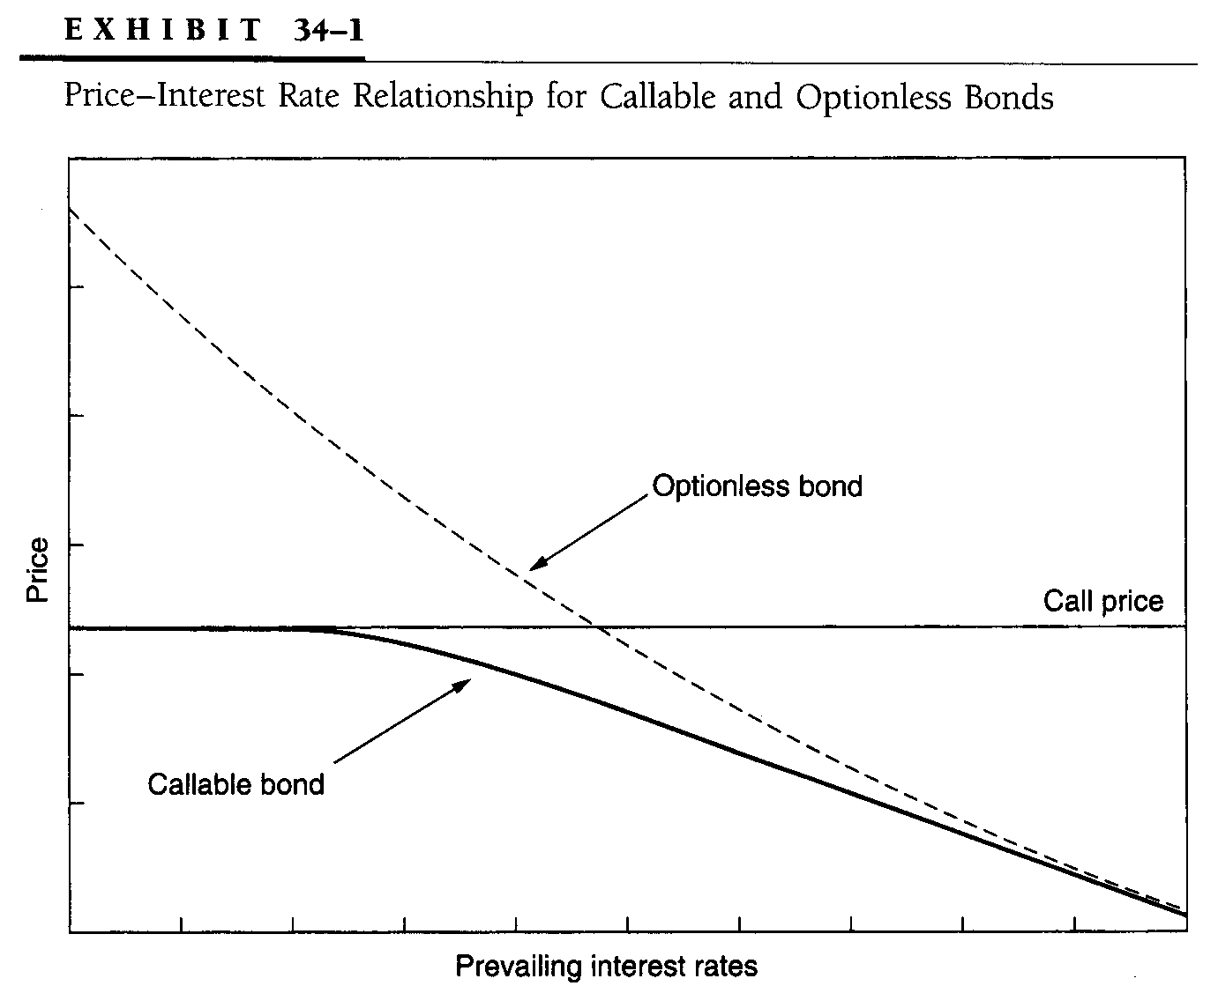
  - Typically, there is an initial period of call protection, after which the bond is callable at any time at a premium to par
  - An American call option has an exercise price that varies over time
  - For putable bonds, the holder has the right to sell the bond to the issuer at a designated time and price

Putable bond value = Optionless bond value + Put option value
- A GENERALIZED MODEL FOR VALUING BONDS WITH EMBEDDED OPTIONS
  - The difference between the values of a bond with an option and an otherwise identical bond without that option is the value of the option
  - Discount each cash flow at its own spot rate
- VALUATION OF OPTIONLESS BONDS
  - The value of an optionless bond is the present value of its cash flows discounted at the spot rate
  - One begins with the issuer’s non-call-life yield curve
    - This is obtained by adding an appropriate credit spread to each on-the-run Treasury issue
    - The credit spreads tend to increase with maturity

  - A bond’s value can be determined in either of two ways
    - The cash flows can be discounted at the zero-coupon or spot rates
    - The cash flows can be discounted year-by-year at the forward one-year rates
- BINOMIAL INTEREST-RATE TREE
  - The Tree

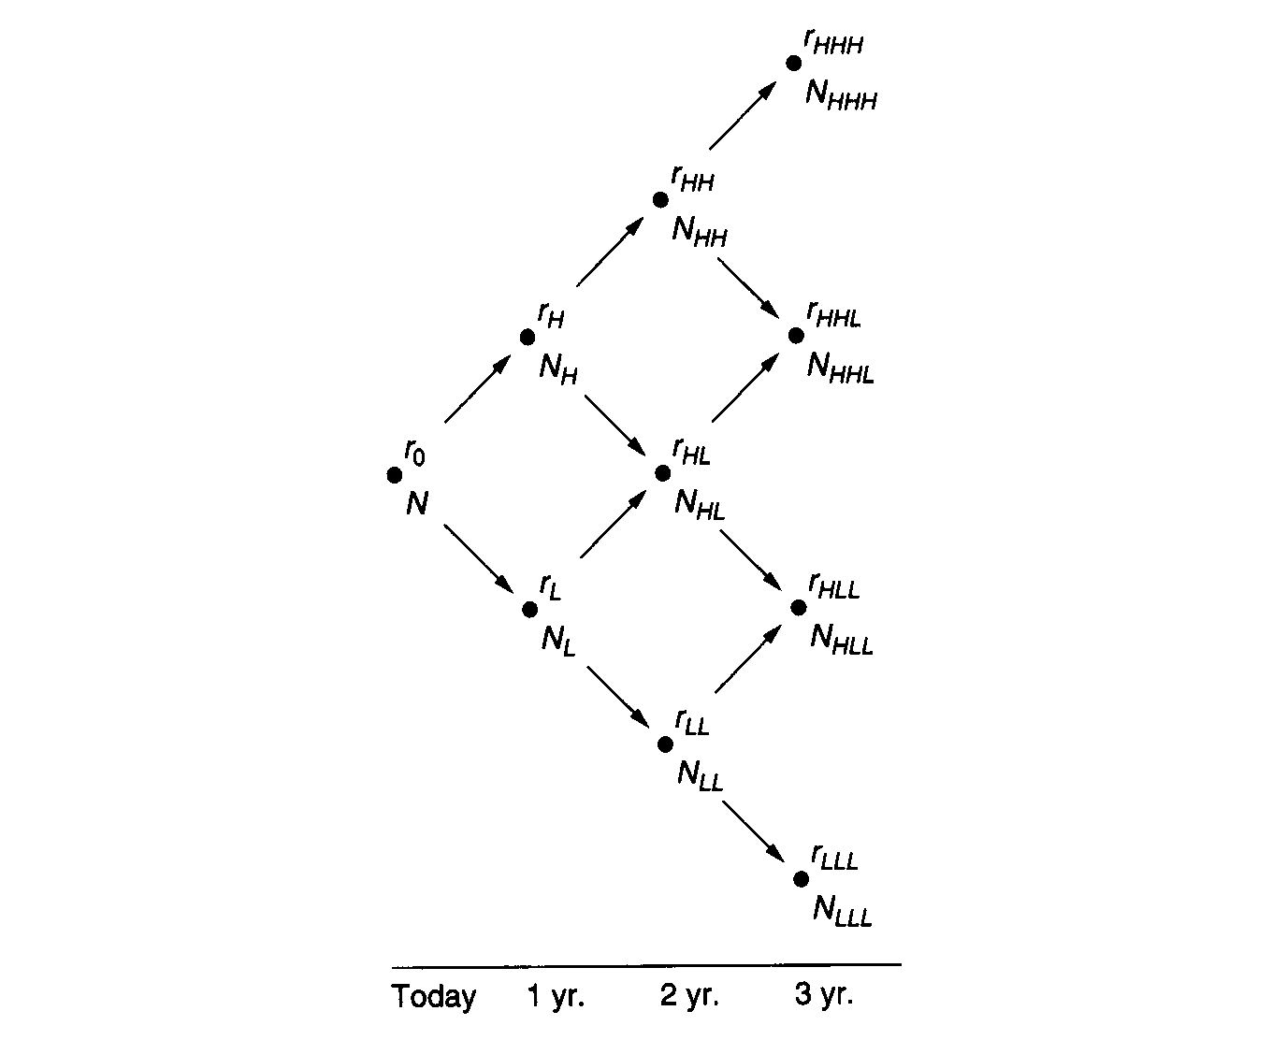
    - The point denoted by N
      - This is the root of the tree
      - Simply the current one-year rate, r₀
    - In creating this tree, we have assumed that the one-year rate will take on one of two equally likely values after each one-year period elapses
      - We construct the tree so that the logarithm of the one-year rate obeys a binomial distribution with p = ½
    - The following notation describes the tree in the first year
      - σ = Assumed volatility of the one-year rate
      - r_{L} = The lower one-year rate one year forward
      - r_{H} = The higher one-year rate one year forward
      - where r_{H} = r_{L}e^{2σ}
  - Volatility and Standard Deviation
    - The standard deviation of the one-year rate one year forward at any node is approximately rσ
    - The volatility is expressed relative to the level of the one-period rate at each node in the tree
  - Determining the Value at a Node
    - A bond’s value at node N is given by

$$V=\frac{1}{2}\left(\frac{V_{H}+V_{L}+2C}{1+r}\right)$$

where V_{H} = The bond’s value along the upper path

V_{L} = The bond’s value along the lower path

C = The coupon payment

r = The one-year rate at N
  - Valuing an Optionless Bond
    - Because the tree was calibrated to value the on-the-run securities, it will necessarily value any contractual set of cash flows correctly
  - Valuing a Callable Bond
    - The valuation process is the same as for an optionless bond, with one exception
      - When the call option can be exercised by the issuer, the bond’s value at the node must be changed to reflect the lesser of
        - The call price
        - The present value of the future cash flows
    - Actual exercise strategies may involve the sacrifice of some time value and entail tax and accounting considerations
  - Determining the Value of the Call Option

Value of call option = Value of optionless bond — Value of callable bond
  - Extension to Other Embedded Options
    - A putable bond
      - When the put option can be exercised by the issuer, the bond’s value at the node must be changed to reflect the greater of
        - The put price
        - The present value of the future cash flows

Value of put option = Value of putable bond — Value of optionless bond
  - Volatility and the Theoretical Value
    - The volatility assumption has an important impact on the theoretical value of option-bearing securities
      - The higher the volatility, the higher the value of any option, including one embedded in a bond
      - For a callable bond, greater volatility increases the value of a call option and so decreases the value of the bond
      - For a putable bond, greater volatility increases the value of a put option and hence increases the value of a putable bond
  - Option-Adjusted Spread
    - This model determines the theoretical value of a bond
    - This value can then be compared to the observed market price
    - The market convention has been to quote a nominal spread — the difference between the yield-to-maturity on a particular bond and that on a Treasury bond of comparable maturity
    - This approach can be extended to take into account the entire yield curve, through either a set of spot rates or a set of forward rates
    - We seek the constant spread that, when added to all the forward rates on the tree, makes the theoretical value equal to the market price
    - This quantity is called the option-adjusted spread (OAS)
    - Like the value of an option-bearing bond, the OAS will depend on the volatility assumption
    - For a given bond price, the higher the interest-rate volatility, the lower the OAS for a callable bond and the higher the OAS for a putable bond
  - Effective Duration and Effective Convexity
    - Modified duration is not an appropriate measure for bonds with embedded options whose cash flows can change with changing interest rates
    - The correct duration measure — called effective duration — quantifies the price sensitivity to small changes in interest rates while simultaneously allowing for changing cash flows
    - In terms of our binomial interest-rate tree, price response to changing interest rates is found by shifting the tree — or, more appropriately, the yield curve from which the tree is derived — up and down by a few basis points

$$\text{Effective} \text{Duration}=\frac{P_{−}−P_{+}}{2(P_{0})(Δy)}$$

$$\text{Effective} \text{Convexity}=\frac{P_{−}−2P+P_{+}}{2(P_{0})(Δy)^{2}}$$

where P₀ = the value of the bond including accrued interest

P₋ = the value of a bond if the entire yield curve is shifted down by Δy bps

P₊ = the value of a bond if the entire yield curve is shifted down by Δy bps
- THE CHALLENGE OF IMPLEMENTATION
  - For use as a practical tool, the basic interest-rate tree requires several refinements
    - The spacing of the node lines in the tree must be much finer, particularly if American options are to be valued
      - However, the fine spacing required to value short-dated securities becomes computationally inefficient if one seeks to value, say, 30-year bonds
      - Although one can introduce a time-dependent node spacing, caution is required
      - It is easy to distort the term structure of volatility
    - Other practical difficulties include the management of cash flows that fall between two node lines

