The Handbook of Fixed Income Securities
Notes by Day Yi
Chapter 26:

Collateralized Mortgage Obligations
- PASS-THROUGHS AND WHOLE LOANS: THE BUILDING BLOCKS OF CMOS
  - Collateral
    - Individual home mortgages are the underlying collateral and source of cash flow for CMOs
    - In the case of agency CMOs, these mortgages are already pooled and securitized in pass-through form
    - Whole-loan CMO issuers do not take the interim step of creating a pass-through security from a pool of individual mortgages
      - They create a structure directly based on the cash flows of a group of mortgages
      - The most common distinguishing characteristic of whole loans is their size
        - The agencies accept only mortgages below a certain size (currently $252,700 for FNMA and FHLMC and $219,849 for GNMA)
        - Larger loans, known as jumbo loans, make up the primary collateral for whole-loan CMOs
  - Credit
    - GNMA is a U.S. government agency, and FHLMC and FNMA are government-sponsored enterprises
      - GNMA securities, like U.S. Treasury securities, are backed by the full faith and credit of the U.S. government
      - FNMA and FHLMC are federally chartered corporations and the market assumes an implicit U.S. government guarantee backing the agency guarantee
    - Although whole loans do not carry agency guarantees against default, they generally adhere to agency underwriting standards for types of documentation required, loan-to-value ratios, and income ratios
      - In addition, the rating agencies require significant levels of credit enhancement to obtain a AAA or AA rating
      - The combination of collateral quality and structural features make it highly unlikely that investors in senior classes of whole-loan CMOs will sustain credit-related losses
  - Prepayments
    - Three collateral characteristics are necessary for evaluating collateral from a prepayment perspective
      - Issuer/guarantor
        - GNMAs are backed by loans insured by the Federal Housing Administration (FHA) or guaranteed by the Veterans Administration (VA)
          - FHA/VA borrowers (GNMA) tend to be less mobile than non-FHA/VA (conventional) borrowers
          - GNMA prepayments have been slower and more stable than conventional prepayments
          - Whole loans tend to be larger and therefore represent more wealthy or sophisticated borrowers
          - In falling rate environments, they have prepaid approximately 1.5-2 times faster than comparable coupon conventionals
      - Gross weighted average coupon (WAC)
        - The average of the interest rates of the mortgages backing a structure before adjusting for the servicing fee
      - Weighted average loan age (WALA) or weighted average maturity (WAM)
        - Loan age is important in determining short-term prepayments
        - The best measure of age is WALA, which tracks the age of the underlying mortgages
        - If WALA is not available, then taking the original term of the mortgages and subtracting the WAM will give an approximation
- CMO STRUCTURES
  - Introduction
    - In a CMO, cash flows from one or more mortgage pass-throughs or a pool of mortgages are reallocated to multiple classes with different priority claims
    - The CMO is self-supporting, with the cash flows from the collateral always able to meet the cash-flow requirements of the CMO classes under any possible prepayment scenario
    - Important points about CMO structures
      - Since credit risk is not an issue for agency CMOs, there is no need for credit enhancements in the structures
      - Whole-loan CMOs do not carry government default guarantees and are therefore usually rated by the bond rating agencies
        - A variety of credit enhancement techniques are employed so that most or all bonds in a structure receive a AAA rating
        - The most common technique today is the senior/ subordinated structure, with senior bonds generally rated AAA and layers of subordinated bonds receiving lower investment- or noninvestment-grade ratings
      - Most CMO classes pay interest monthly, based on the current face amount of the class, even if it is not currently paying down principal.
      - Most CMO classes have a principal lockout period during which only interest payments are received
        - In most cases, the lockout period and the payment window are not absolute but are affected by prepayments on the underlying collateral
      - CMO classes are structured with specific cash flow profiles and investment terms based on an assumed prepayment rate
        - This assumed rate, which represents the market’s current expectation of future prepayments on the collateral, is known as the pricing speed
      - CMOs can be structured from collateral of any maturity
    - CMO structures are of two major types
      - One provides for the redirection of principal payments only
      - The other provides for redirection of interest as well as principal
    - Sequential-pay, PAC/companion, and TAC/companion structures redirect principal and are the starting point for all CMOs
  - Sequential-Pay Classes
    - The primary purpose of the first CMOs was to bring a broader range of maturity choices to the MBS market
    - All initial principal amortization and prepayments from the collateral are
      - Paid to the shortest maturity class, or tranche, until it is fully retired
      - Then principal payments are redirected to the next shortest class
      - This process continues until all classes are paid down
    - With the creation of the sequential-pay structure, capital market participants with short investment horizons were able to enter the MBS market because they could buy bonds that more closely matched their desired terms
    - Investors with long-term horizons also benefited because they were insulated from prepayments during the early years of a pool’s life

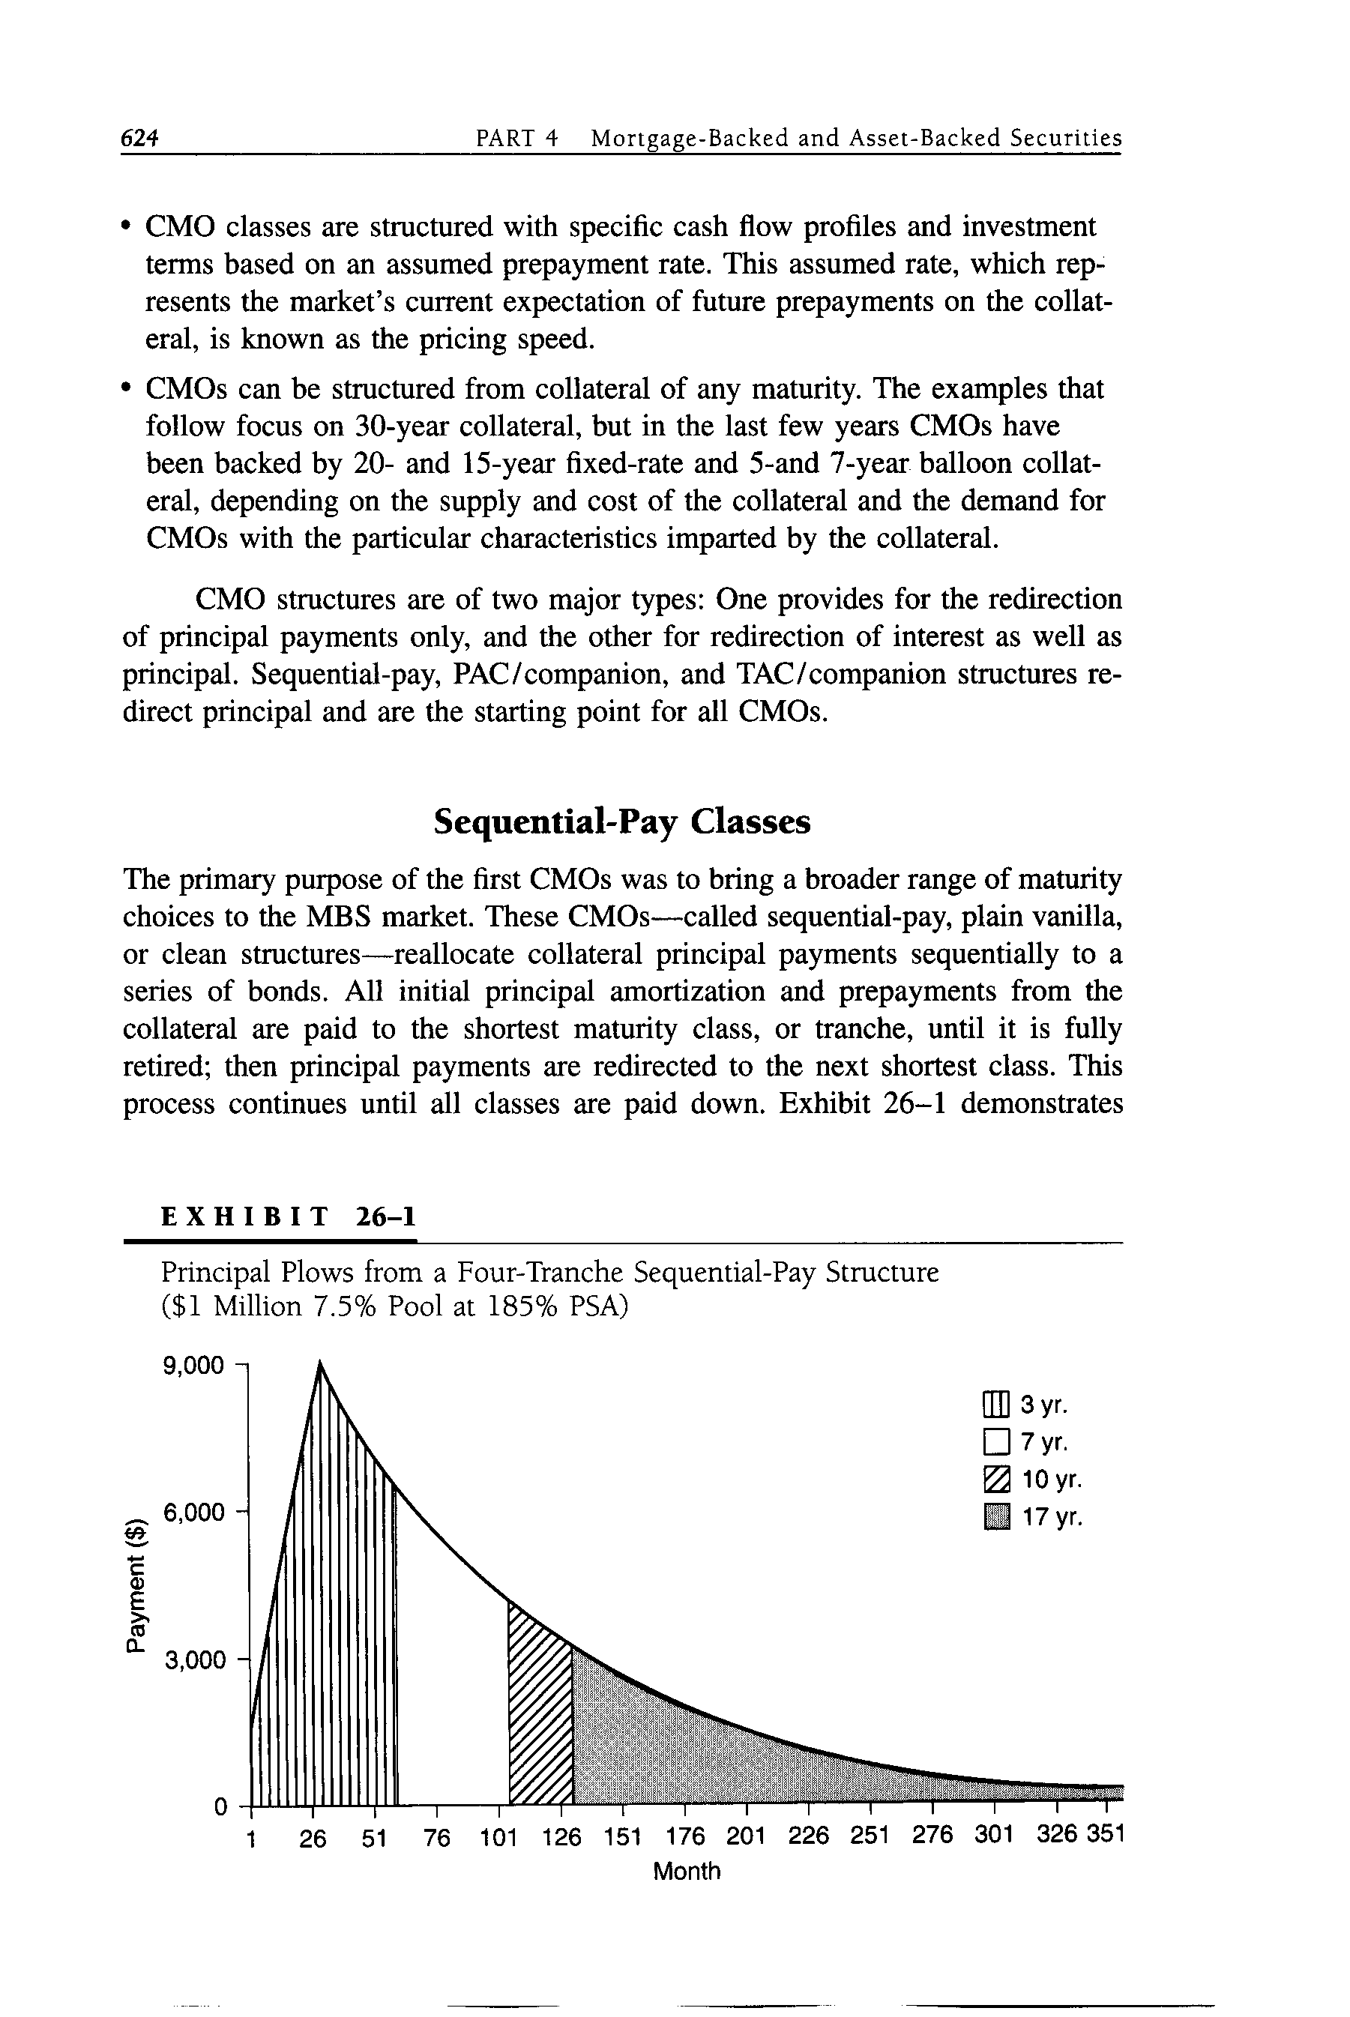
  - Planned Amortization Classes
    - These structures offered substantial protection from the reinvestment risk and weighted average-life volatility associated with prepayments
    - PACs have a principal payment schedule (similar to a sinking fund mechanism) that can be maintained over a range of prepayment rates
      - This schedule is based on the minimum amount of principal cash flow produced by the collateral at two prepayment rates known as the PAC bands

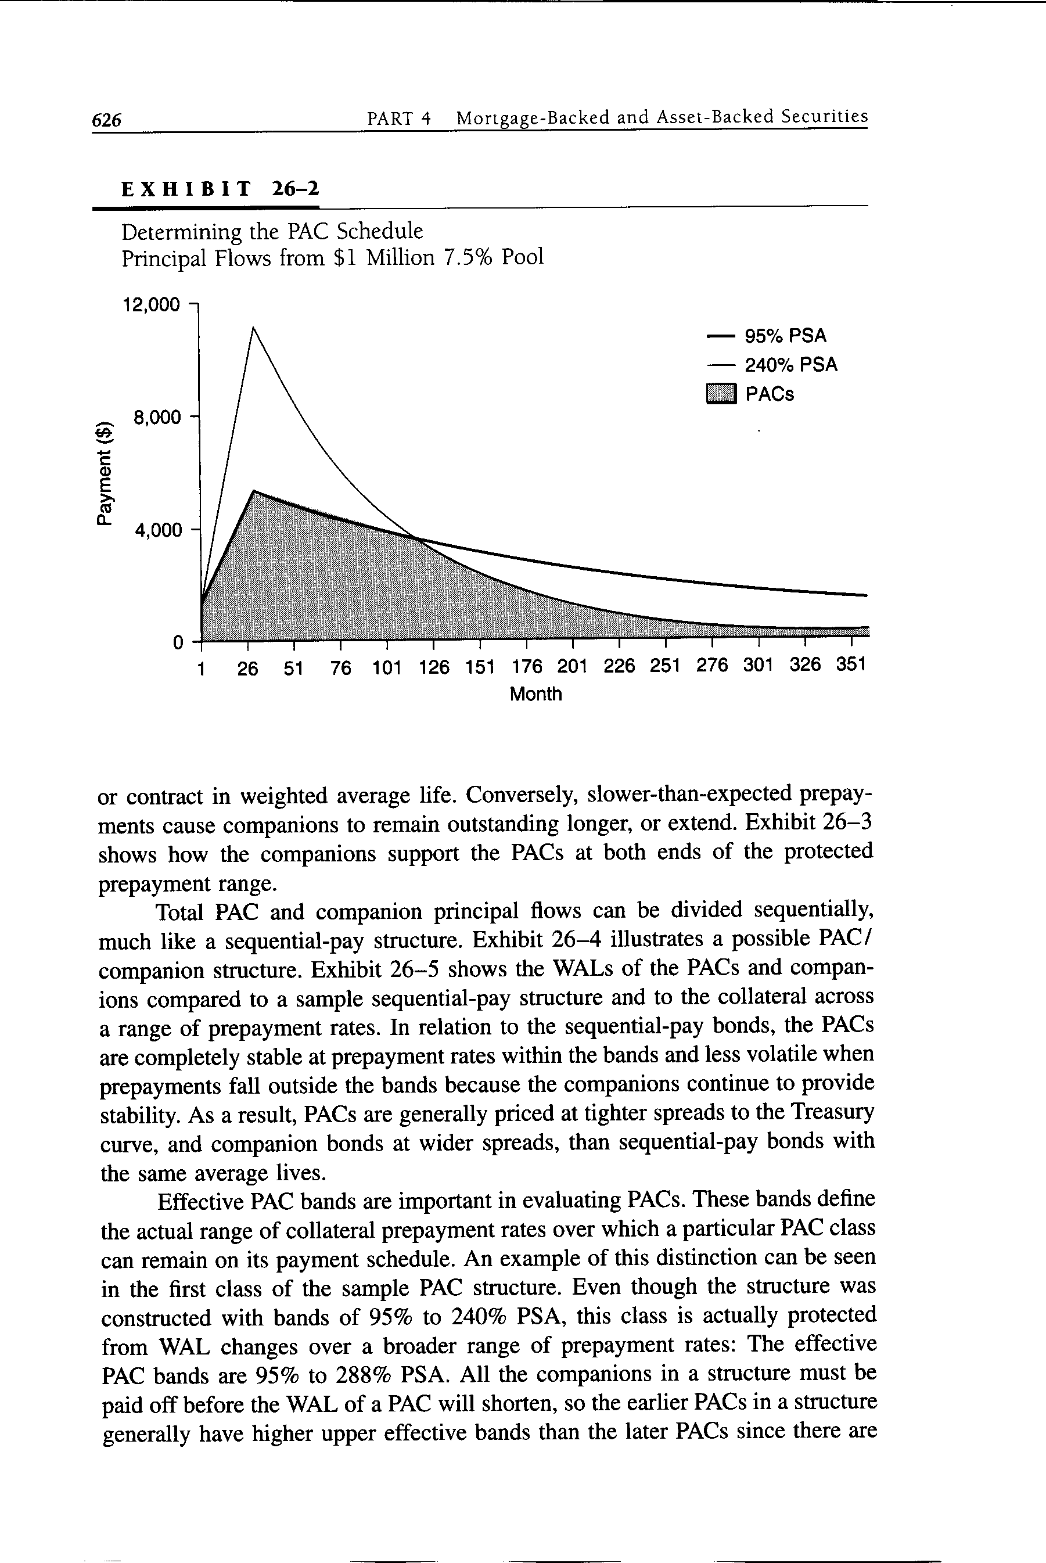
    - The total principal flow available under the PAC schedule determines the original amount of PACs in a structure
    - The PAC schedule is maintained by redirecting cash flow uncertainty to classes called companions
      - In times of fast prepayments, companions support PACs by absorbing principal payments in excess of the PAC schedule
      - In times of slow prepayments, amortization of the companions is delayed if there is not enough principal for the currently paying PAC

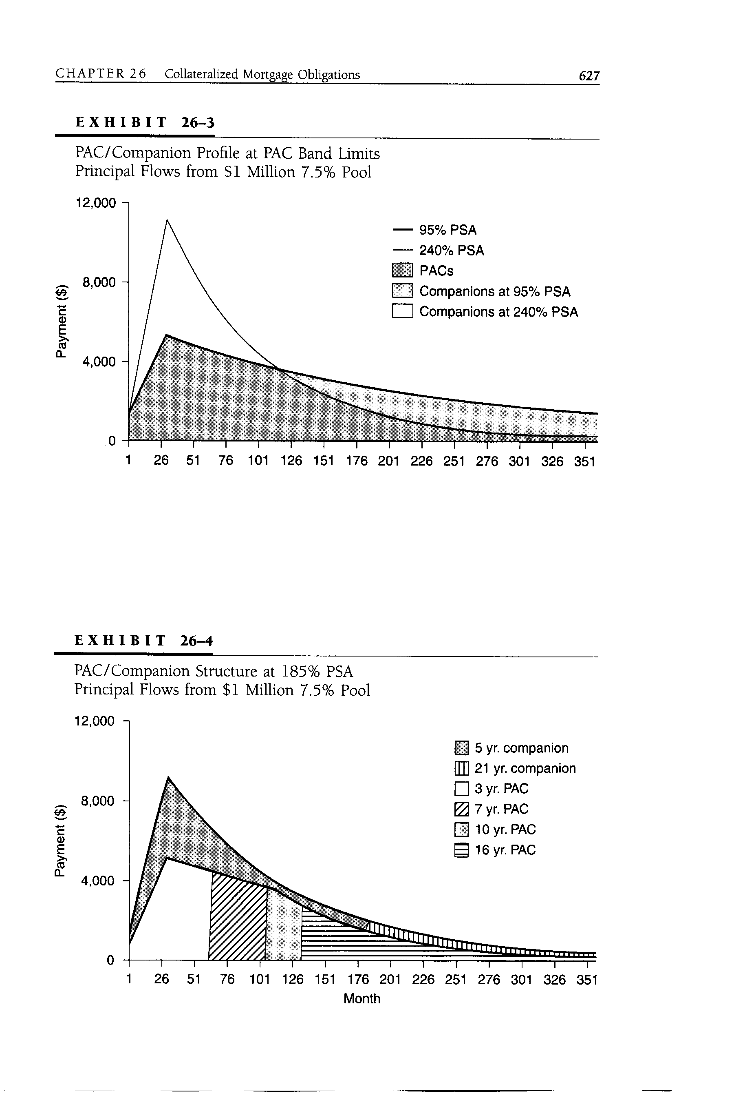
    - Total PAC and companion principal flows can be divided sequentially
    - Effective PAC bands are important in evaluating PACs
      - These bands define the actual range of collateral prepayment rates over which a particular PAC class can remain on its payment schedule
    - PAC variants (protection levels and yield tradeoffs)
      - Type II and Type III PACs
        - The resulting innovation was the Type II PAC, structured from companion cash flows in a PAC/companion structure
        - These bonds have narrower prepayment protection bands than standard PACs
        - Because Type II PACs are second in priority to PACs, the remaining companion bonds provide support even if prepayments are outside the bands
        - If extended periods of high prepayments cause the companions in a structure to be paid off, the remaining Type II PACs become companions to the PACs, with the potential WAL volatility of companion bonds

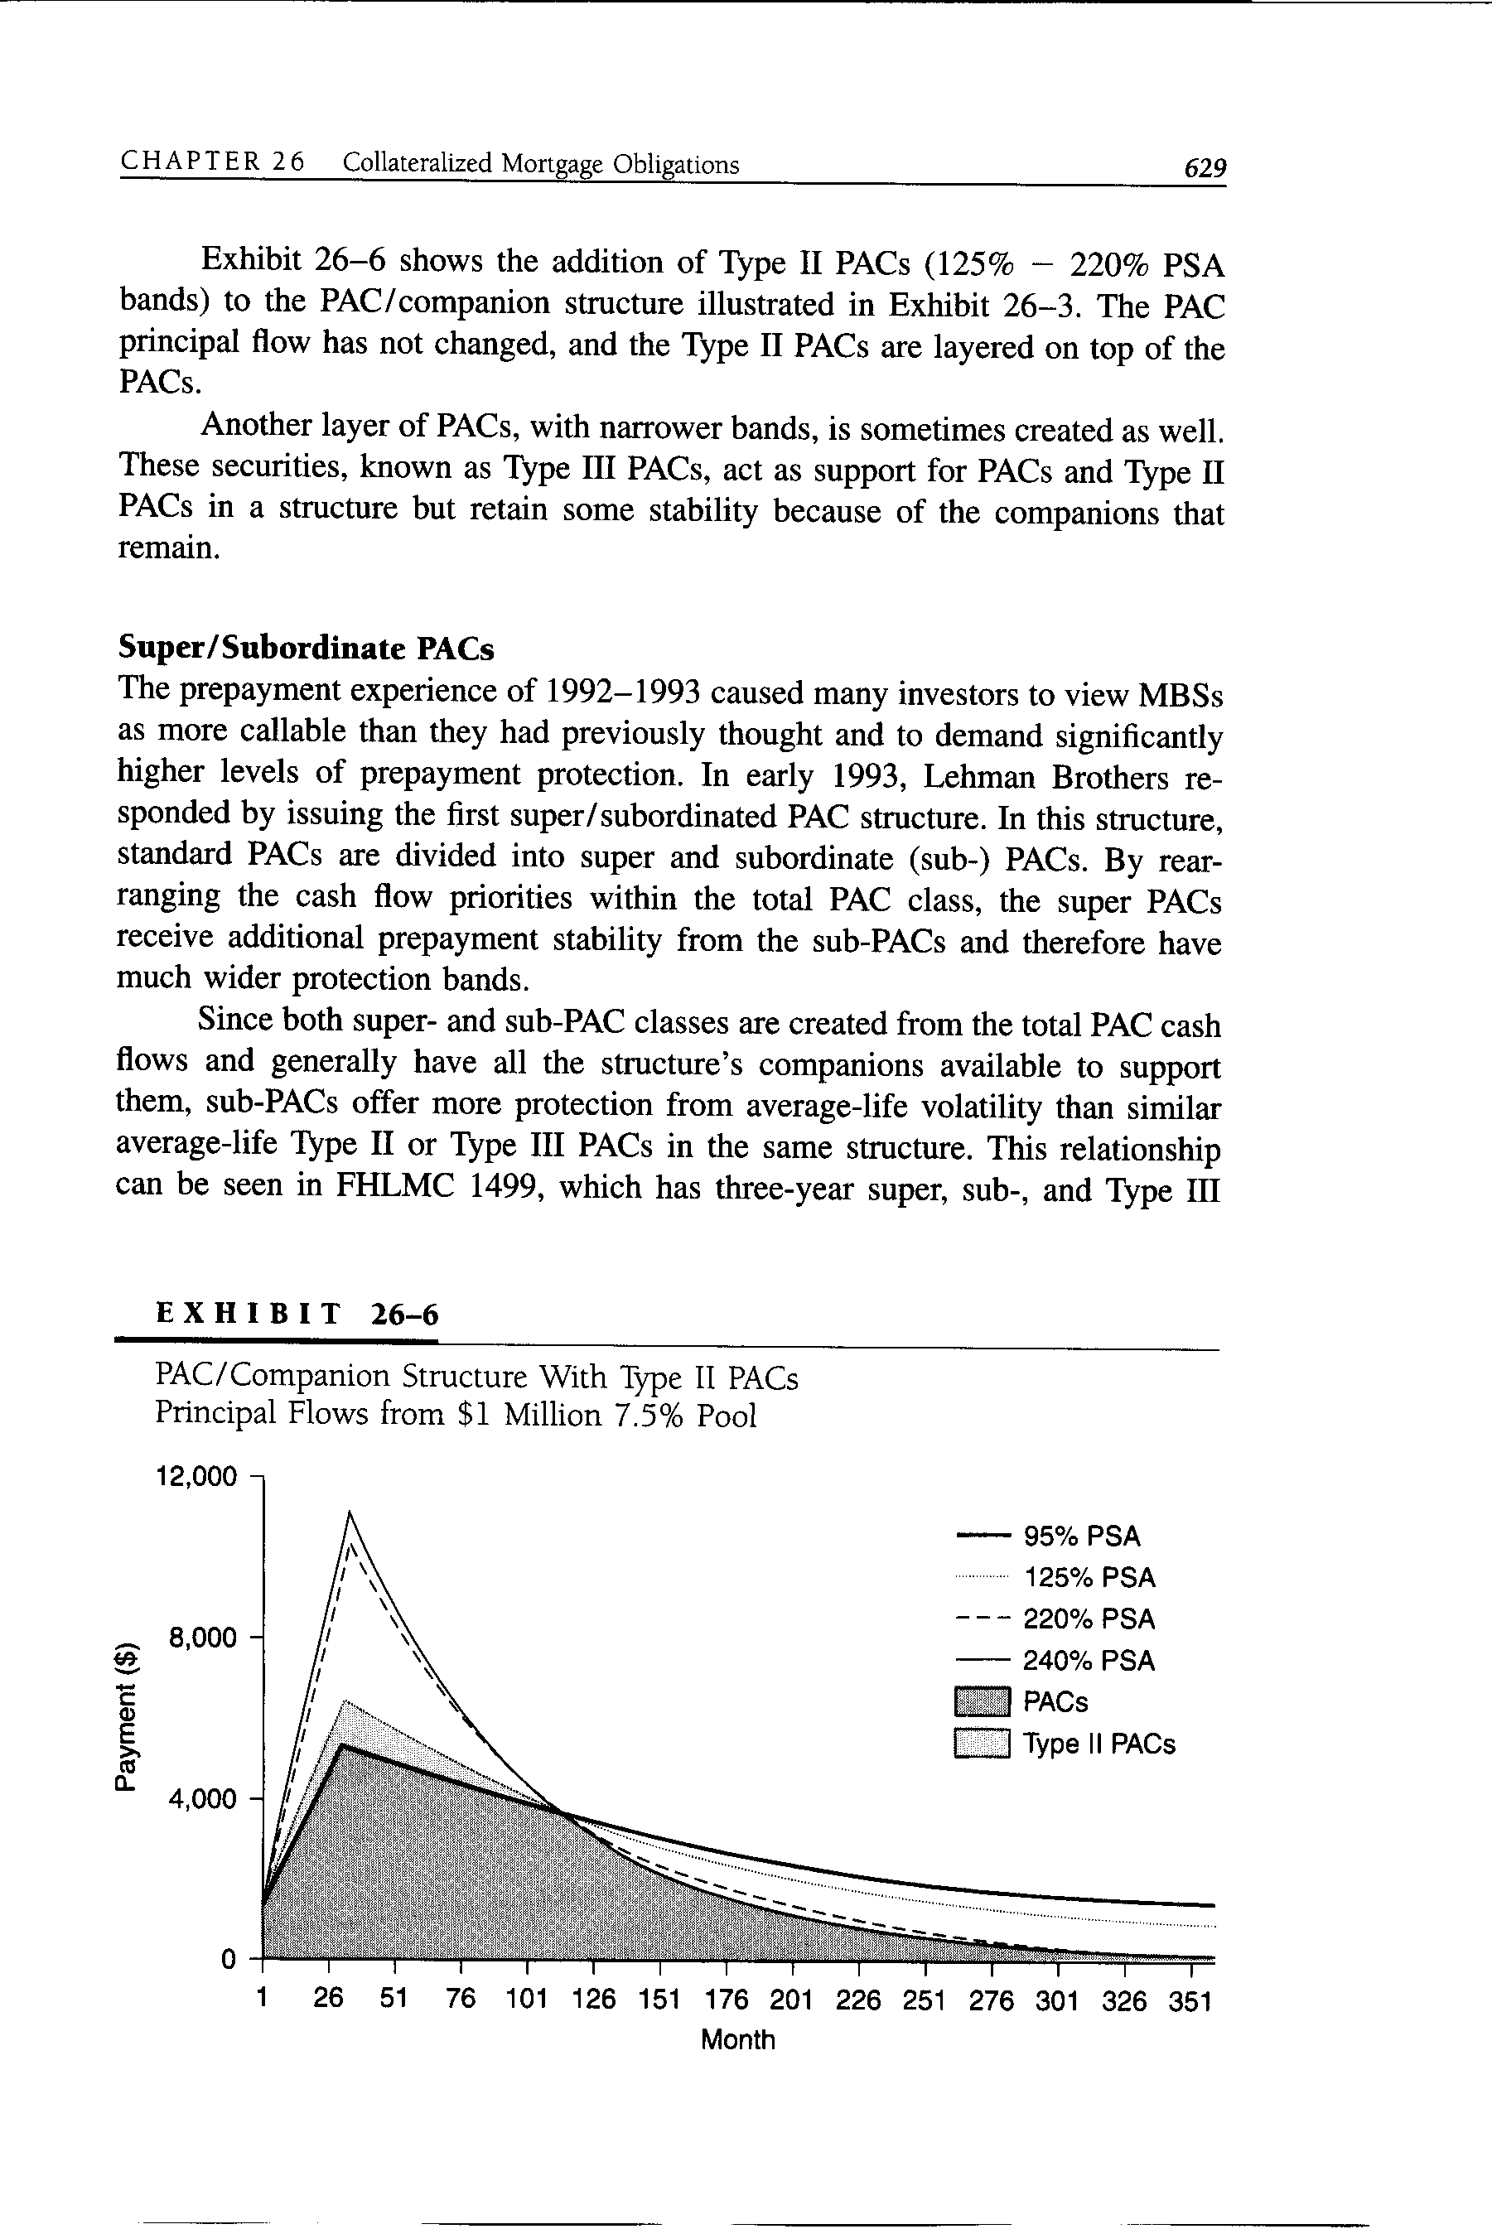
        - Another layer of PACs (Type III PACs), with narrower bands, is sometimes created as well
          - Act as support for PACs and Type II PACs in a structure
          - Retain some stability because of the companions that remain
      - Super/Subordinate PACs
        - In early 1993, Lehman Brothers issued the first super/subordinated PAC structure
          - Standard PACs are divided into super and subordinate (sub-) PACs
          - By rearranging the cash flow priorities within the total PAC class, the super PACs
            - Receive additional prepayment stability from the sub-PACs
            - Have much wider protection bands
        - Sub-PACs offer more protection from average-life volatility than similar average-life Type II or Type III PACs in the same structure since both super- and sub-PAC classes are
          - Created from the total PAC cash flows
          - Generally have all the structure’s companions available to support them

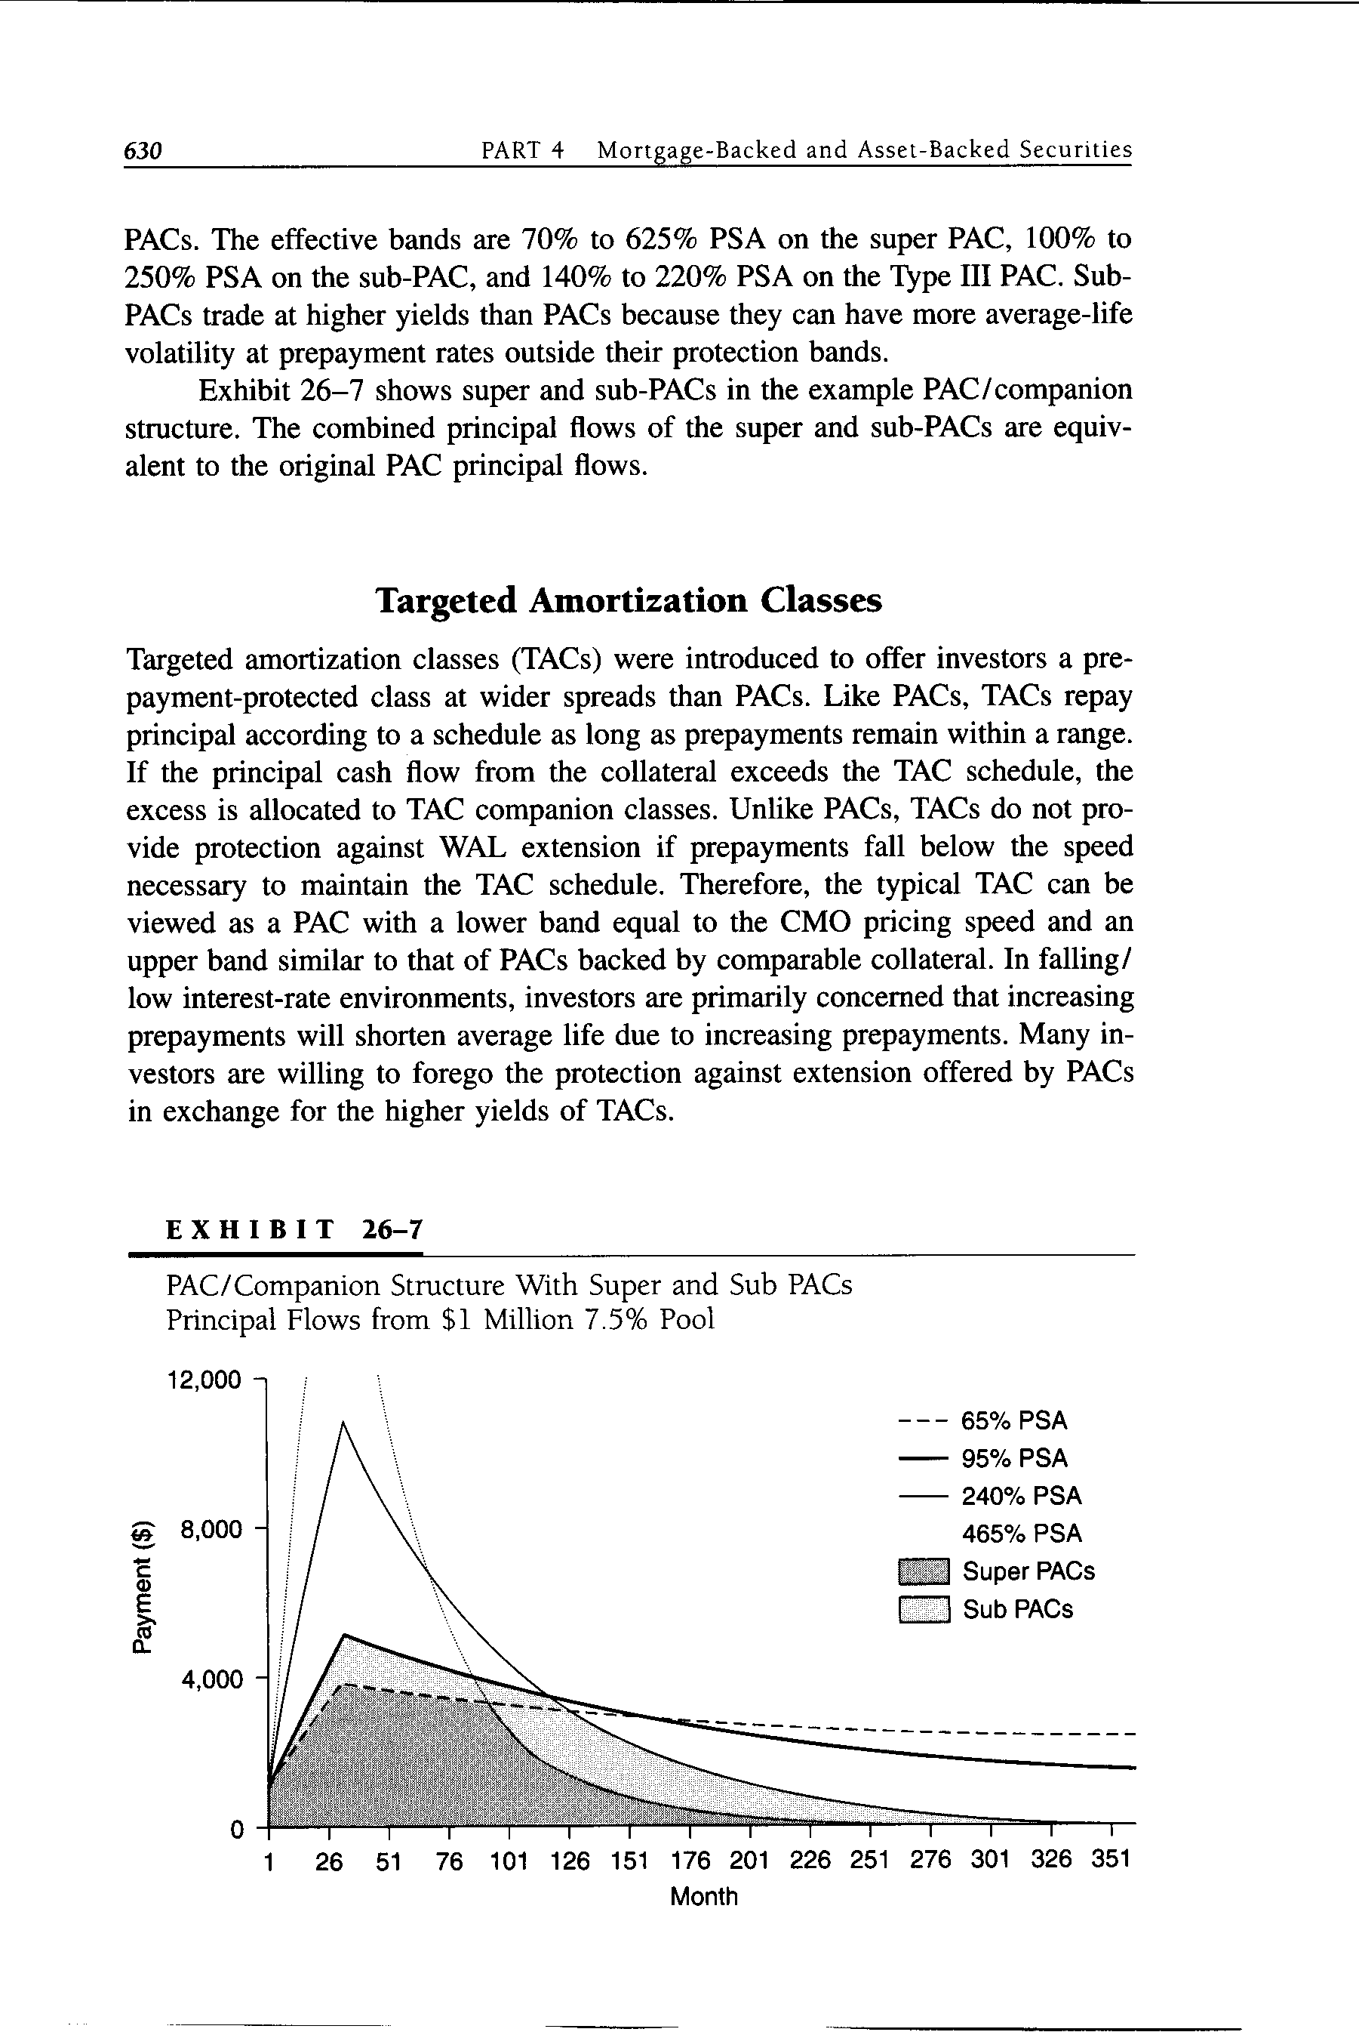
  - Targeted Amortization Classes
    - Targeted amortization classes (TACs) were introduced to offer investors a prepayment-protected class at wider spreads than PACs
    - Like PACs, TACs repay principal according to a schedule as long as prepayments remain within a range
    - If the principal cash flow from the collateral exceeds the TAC schedule, the excess is allocated to TAC companion classes
    - Unlike PACs, TACs do not provide protection against WAL extension if prepayments fall below the speed necessary to maintain the TAC schedule
    - Therefore, the typical TAC can be viewed as a PAC with
      - A lower band equal to the CMO pricing speed
      - An upper band similar to that of PACs backed by comparable collateral
    - Many investors are willing to forego the protection against extension offered by PACs in exchange for the higher yields of TACs.
  - Companions
    - A class that provides prepayment protection for another class
    - The behavior of a particular companion class is influenced by the class(es) it supports
    - Other bonds in the structure may affect the companion’s potential performance
    - Another important consideration for companions is the collateral backing the CMO
    - A class’s sensitivity to prepayments should be viewed in a yield or total return context
      - Faster-than-expected prepayments will have a positive effect on a discount bond’s yield
      - Slower-than-expected prepayments will have a positive effect on a premium bond’s yield
  - Z Bonds
    - The Z bond is a CMO class with a period of principal and interest lockout
    - It typically takes the place of a coupon-bearing class at or near the end of a CMO structure
    - Each month that the Z is outstanding, it generates coupon cash flows, like any other bond in the structure
    - As long as the Z class is not paying out principal, this coupon flow is used to pay down other classes
    - The Z gets credit for the foregone interest payments through increases to its principal balance, known as accretion
    - Once the classes preceding the Z bond are fully paid down, it begins to receive principal and interest
    - In a simple sequential-pay/Z bond structure, the Z accelerates the principal repayments of the sequential-pay bonds
      - As a result, restructuring a sequential-pay bond as a Z allows for larger sequential-pay classes with the same WALs as the original classes
    - Although WAL volatility has decreased, the price sensitivity of the last class is increased dramatically by making it a Z
    - Z bonds offer much of the appeal of zero coupon Treasury strips
  - Accretion-Directed Classes
    - Accretion-directed (AD) bonds are designed to protect against extension in average life if rates rise and prepayments are lower than expected
    - These bonds, also known as very accurately defined maturity (VADM) bonds, derive all their cash flows from the interest accretions of a Z class
    - Because there is no deviation in Z accretions until the Z bond begins to pay down, VADMs do not extend even if there are no prepayments
    - VADMs are also protected from prepayment increases because the Z bonds that support them tend to be the last classes to begin repaying principal
  - Floaters and Inverse Floaters
    - These classes are created by dividing a fixed-rate class into a floater and an inverse floater
      - The bonds take their principal paydown rules from the underlying fixed-rate class
      - A floater/inverse combination can be produced from a sequential-pay class, PAC, TAC, companion, or other coupon-bearing class
      - The coupon of the floater is reset periodically (usually monthly) at a specified spread, or margin, over an index
      - Floaters and inverses have caps and floors that set the maximum and minimum coupons allowable on the bonds
    - Floaters are usually designed to be sold at par
      - Their caps and margins are dictated by
        - The option and swap markets
        - Expectations about the performance of the underlying fixed-rate CMO class
      - To increase the yield, cap, and initial coupon, inverses are often structured with multipliers in the coupon formulas that magnify movements in the underlying index
  - Interest- and Principal-Only Strips
    - Any pool of coupon-bearing collateral can be stripped into interest-only (IO) and principal-only (PO) segments and sold separately
      - Since interest cash flows exist only if principal remains outstanding, IOs benefit from slowing prepayments
      - If prepayments rise, discounted principal flows are received at par earlier than expected, improving the security’s performance
      - IOs are bearish securities and usually have negative durations
      - POs are bullish securities with long positive durations
    - The same principles for stripping pools of collateral can be applied to individual CMO classes or to blocks of classes within a single structure
    - Strips made from CMO bonds require more analysis than regular IOs and POs
    - Another type of strip results from the creation of whole-loan CMOs
- PAC BAND DRIFT
  - Effective PAC bands change (drift) over time, even if prepayments remain within the initial bands
  - Band drift results from
    - The interaction of actual prepayments and the current PAC bands
    - The resulting changes in collateral balance and relative PAC and companion balances
  - The band drift of a particular PAC can be viewed under three scenarios
    - When prepayments are within the current effective bands
      - The currently paying PAC will pay on schedule
      - Any additional prepayments will go to the currently paying companion
      - Over time, both upper and lower bands will drift up
      - For most prepayment rates within the bands
        - The upper band will rise at a faster rate than the lower
        - So prepayments within the bands tend to cause the bands to widen over time
    - When prepayments are above the current upper band
      - The PAC will continue to pay on schedule until all companions are retired
      - If the fast prepayments are only temporary, there will probably be little impact on the bands
      - If prepayments remain above the upper band, the upper and lower bands will begin to converge because there are
        - Fewer companions available to absorb fast prepayments
        - Less collateral outstanding to generate principal cash flows if prepayments slow
      - The bands will converge once all companions have been retired, and the PAC will pay like a sequential-pay class from that point
    - When prepayments are below the current lower band
      - The currently paying PAC will not be able to pay according to its schedule since there will be no other principal flows coming into the structure that can be redirected to the PAC
      - This is typically a temporary situation because
        - The lower band is usually substantially lower than the base prepayment rate expected from simple housing turnover
        - Most PACs have priority over all subsequent cash flows until they are back on schedule
      - Prepayments below the current lower band
        - Cause the upper band to rise (more companions are available to absorb faster prepayments in the future)
        - May cause the lower band to rise slightly (since most PACs have catch-up features, a higher future prepayment rate is necessary to put the PAC back on schedule)
  - Most band drift is small and gradual
    - Large changes to PAC bands will occur only if
      - Prepayments are significantly outside the bands
      - Prepayments remain near either of the bands for a long period of time
    - Effective bands represent the range of prepayment rates that the collateral can experience for its remaining life and still maintain the payment schedule for a specific PAC
    - Temporary movements outside the bands will not affect PAC cash flows as long as companion cash flows and principal balances are available to support them
- REGULATORY DEVELOPMENTS AFFECTING CMOS
  - Federal tax law treated payments from a multiclass trust as equity dividends
    - Unlike debt payments, dividend payments are not tax deductible
  - CMOs were subject to constraints to ensure that they were treated as debt instead of equity for tax purposes
    - Issuers had to
      - Maintain a portion of residual interests
      - Record CMOs as liabilities in their financial statements
      - Satisfy minimum capital requirements
      - Include a call provision, forcing them to price longer maturity bonds at a wider spread to the Treasury curve
      - Structure a mismatch between receipts on the underlying mortgages and payments to the CMO bondholders
    - These constraints made it difficult to issue CMOs efficiently
  - Toward the end of 1985, issuers overcame some of these obstacles by issuing CMOs through an owner’s trust
    - This mechanism allowed issuers to
      - Sell their residual interests and
      - Remove the debt from their books
    - The owner’s trust was not conducive to a liquid market because residual buyers became personally liable for the CMO
  - The 1986 Tax Reform Act addressed these problems by defining a new issuance vehicle: the real estate mortgage investment conduit (REMIC)
    - To qualify for REMIC status, a multiclass offering can have
      - Multiple classes of regular interests
      - But only one class of residual interest
    - The legislation defines a regular interest as a fixed principal amount with periodic interest payments or accruals on the outstanding principal balance
    - A residual interest consists entirely of pro rata payments (if any)
  - REMIC legislation was a milestone in the development of multiclass mortgage securities because it allowed issuers to
    - Adopt whatever structure best exploited particular economic, financial, or accounting considerations
    - Sell the entire residual class
  - Until 1988, private issuers (primarily investment bankers and home builders) accounted for almost the entire supply of multiclass mortgage securities
  - In 1988, FHLMC and FNMA gained full authorization to issue REMICs
  - By 1988, regulatory and market developments had stimulated demand for multiclass mortgage securities
  - Since about 1988, insurance companies have looked to the REMIC market for assets to offset intermediate to long-term liabilities
    - At year-end 1993, life insurance companies implemented their own risk-based capital requirements, which provided an additional incentive to hold mortgages in securitized form
- EVALUATING CMOS
  - The most common way to communicate the value and performance expectations of a CMO bond is the yield table, showing cash flow yields under a series of prepayment rate assumptions
    - Computer models that produce yield tables
      - Take prices and prepayment rates as inputs (and index levels, in the case of floaters and inverse floaters)
      - Calculate
        - Yields and spreads
        - Average lives
        - Durations
        - Payment windows for each prepayment assumption
    - With this information, the investor can determine the
      - Level of prepayment protection offered by the bond
      - Average life volatility for given changes in collateral prepayment rates
      - Impact of prepayments on yields
      - Time over which principal is likely to be received
  - Total return scenario analysis may also be used to evaluate CMOs
    - It addresses two drawbacks of the cash-flow yield approach
      - Many investors do not expect to hold their securities to maturity
      - The reinvestment assumption in the cash flow yield analysis — that all cash flows are reinvested at the security’s yield — is usually unrealistic
    - Total return calculations
      - Cover a specific investment period
      - Make an assumption about
        - The bond’s price at the end of the period (the horizon)
        - A reinvestment rate and prepayment rate for the period to generate cash flows
    - Total return is
      - The sum of
        - The change in market value of the bond
        - The cumulative value of all cash flows and reinvestment proceeds as of the horizon date
      - Divided by the initial market value
  - Option-adjusted spread (OAS) analysis is another relative value measurement tool used by fixed income market participants
    - Cash flows of a callable bond are analyzed to calculate the average spread to the Treasury spot curve implied by the security’s current price
    - Since this process nets out the impact of prepayments (partial calls) of MBSs, OAS allows direct comparisons among MBSs and other callable and noncallable fixed income securities
    - Using current OAS to calculate the horizon price of a CMO is a common method in total return analysis
- THE CMO/COLLATERAL PRICING RELATIONSHIP
  - The source of the CMO/collateral pricing relationship is the interplay between
    - The yield curve
    - Spreads on collateral and CMOs
  - When the yield curve is positively sloped, earlier classes are generally offered at lower yields than later classes
- CMO TRADING AND CLEARING
  - Generally, CMO bonds are offered on the basis of a spread over the yield of a benchmark Treasury and a prepayment assumption
  - The CMO market convention is corporate settlement (three business days after the trade date) unless the CMO is a new issue
  - Most agency CMO trades are cleared through electronic book-entry transfers such as Fedwire, a clearing system maintained by the Federal Reserve
  - Whole-loan CMO trades are cleared through physical delivery or electronic book entry, depending on the issuer
  - Most MBSs pay with a delay — the cash flows earned during one month are paid out a fixed number of days after the end of the month to give mortgage servicers time to collect payments

