The Handbook of Fixed Income Securities
Notes by Day Yi
Chapter 05:

Measuring Interest Rate Risk
- THE FULL VALUATION APPROACH
  - The most obvious way to measure the interest rate risk exposure of a bond position or a portfolio is to re-value it when interest rates change
    - The analysis is performed for a given scenario with respect to interest rate changes
    - It is sometimes referred to scenario analysis because it involves assessing the exposure to interest rate change scenarios
  - The full valuation approach can handle scenarios of any yield curve changes (parallel or nonparallel)
  - What scenarios should be evaluated to assess interest rate risk exposure
    - It is common for regulators of depository institutions to require entities to determine the impact on the value of their bond portfolio for a 100, 200, and 300 basis point instantaneous change in interest rates (up and down)
      - Regulators tend to refer to this as “simulating” interest rate scenarios rather than scenario analysis
    - Risk managers and highly leveraged investors, such as hedge funds, tend to look at extreme scenarios to assess exposure to interest rate changes
      - This practice is referred to as stress testing
  - Assumes that the investor has a good valuation model to estimate what the price of the bonds will be in each interest rate scenario
  - The full valuation process can be time consuming
- PRICE VOLATILITY CHARACTERISTICS OF BONDS
  - The characteristics of a bond that affect its price volatility are
    - Maturity
    - Coupon rate
    - Presence of embedded options
    - Level of yields
  - Price Volatility Characteristics of Option-Free Bonds
    - The price/yield relationship for any option-free bond

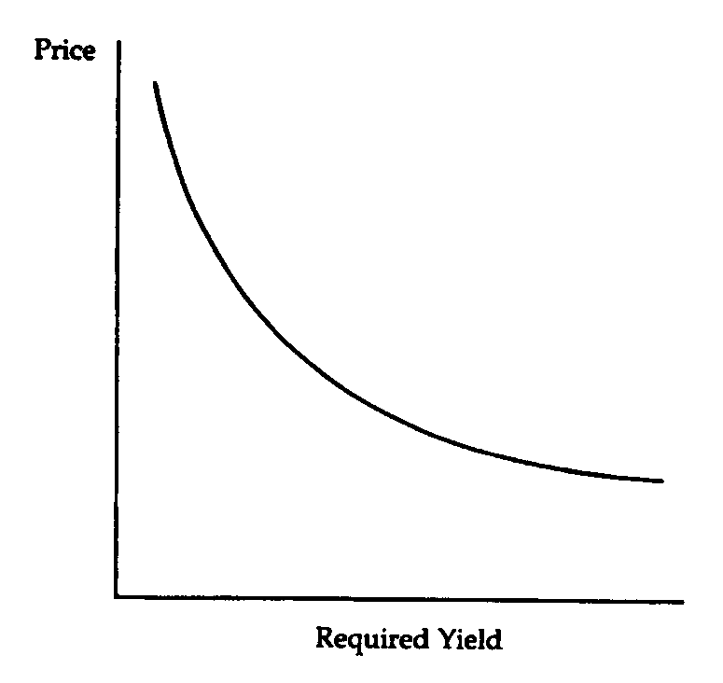
    - This price/yield relationship is for an instantaneous change in the required yield
    - Properties concerning the price volatility of an option-free bond
      - Property 1: Although the price moves in the opposite direction from the change in required yield, the percentage/dollar price change is not the same for all bonds
      - Property 2: For small changes in the required yield, the percentage/dollar price change for a given bond is roughly the same, whether the required yield increases or decreases.
      - Property 3: For large changes in required yield, the percentage/dollar price change is not the same for an increase in required yield as it is for a decrease in required yield
      - Property 4: For a given large change in basis points in the required yield, the percentage/dollar price increase is greater than the percentage/dollar price decrease
    - The implication of Property 4 is that if an investor is long/short a bond
      - The price appreciation that will be realized if the required yield decreases/increases is greater than
      - The capital loss that will be realized if the required yield increases/decreases by the same number of basis points
  - Bond Features that Affect Interest Rate Risk
    - The Impact of Maturity
      - All other factors constant, the longer the bond’s maturity, the greater the bond’s price sensitivity to changes in interest rates
    - The Impact of Coupon Rate
      - A property of a bond is that all other factors constant, the lower the coupon rate, the greater the bond’s price sensitivity to changes in interest rates
    - The Impact of Embedded Options
      - Price of callable bond = Price of option-free bond — Price of embedded call option
  - Price Volatility Characteristics of Bonds with Embedded Options
    - Bonds with Call and Prepay Options

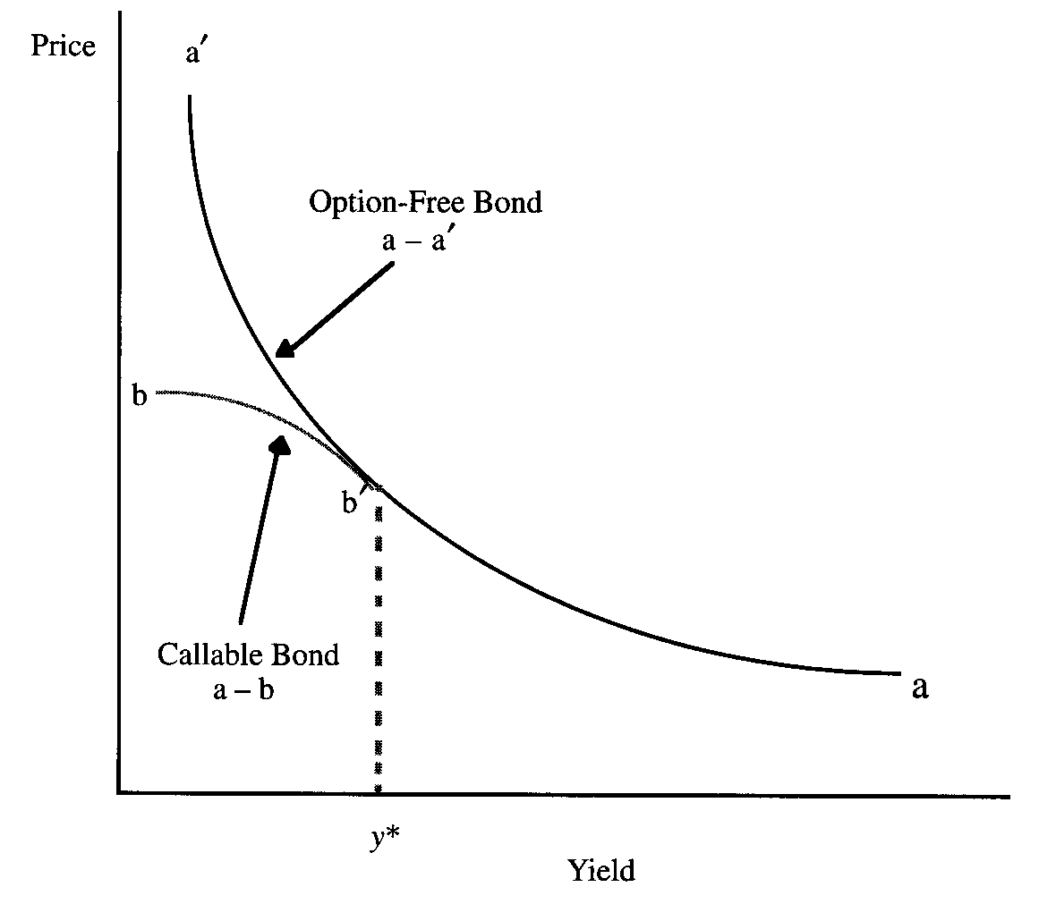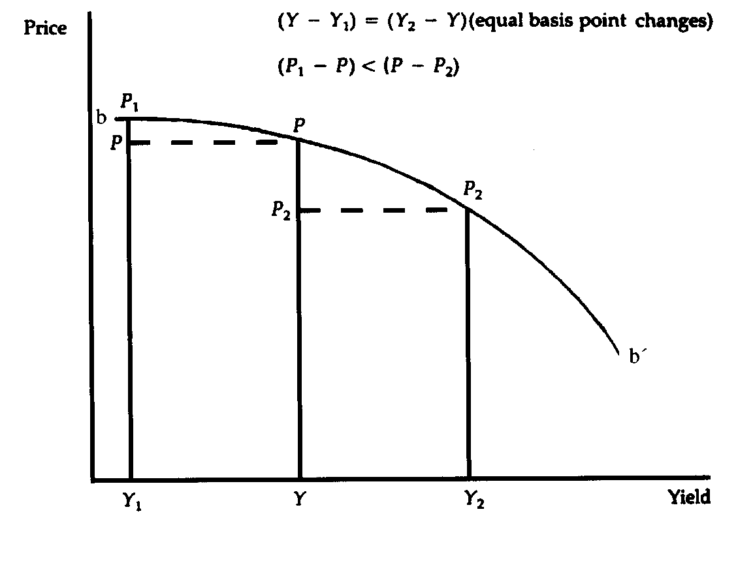

    - Bonds with Embedded Put Options

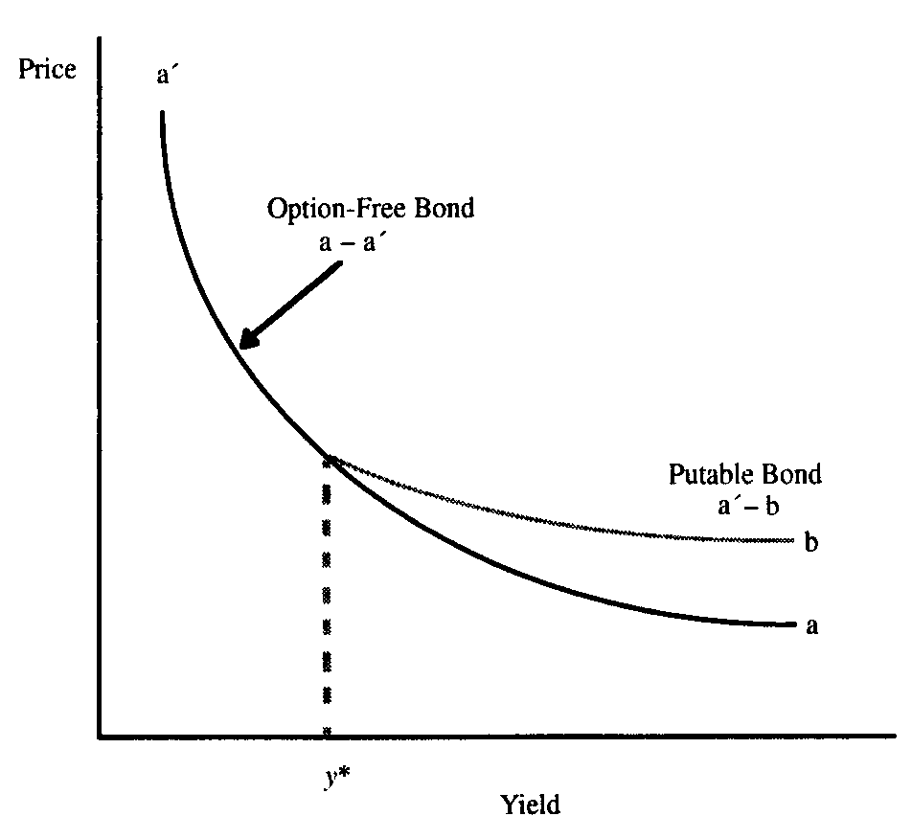
  - Interest Rate Risk for Floating-Rate Securities
    - The price of a floating-rate security will fluctuate depending on three factors
      - The longer the time to the next coupon reset date, the greater the potential price fluctuation
      - The required margin that investors demand in the market changes
      - A floating-rate security will typically have a cap
        - Once the cap is reached, the security’s price will react much the same way to changes in market interest rates as that of a fixed-rate coupon security
        - This risk for a floating-rate security is called cap risk
  - The Impact of the Yield Level
    - Because of credit risk, different bonds trade at different yields, even if they have the same coupon rate, maturity, and embedded options
    - For a given change in interest rates
      - Price sensitivity is lower when the level of interest rates in the market is high
      - Price sensitivity is higher when the level of interest rates is low
- DURATION
  - Calculating Duration
    - The duration of a bond is estimated as follows

$$\text{duration}=\frac{V_{−}−V_{+}}{2(V_{0})(Δy)}$$

where V₋ = price if yields decline by Δy

V₊ = price if yields increase by Δy

V₀ = initial price

Δy = change in yield
    - Duration is interpreted as the approximate percentage change in price for a 100 basis point change in rates
    - Regardless of the yield change used to estimate duration, the interpretation is the same
  - Approximating the Percentage Price Change Using Duration
    - The following formula is used to approximate the percentage price change for a given change in yield and a given duration

approx % price change = - duration x Δy x 100
  - Graphical Depiction of Using Duration to Estimate Price Changes
    - The shape of the price/yield relationship for an option-free bond is convex

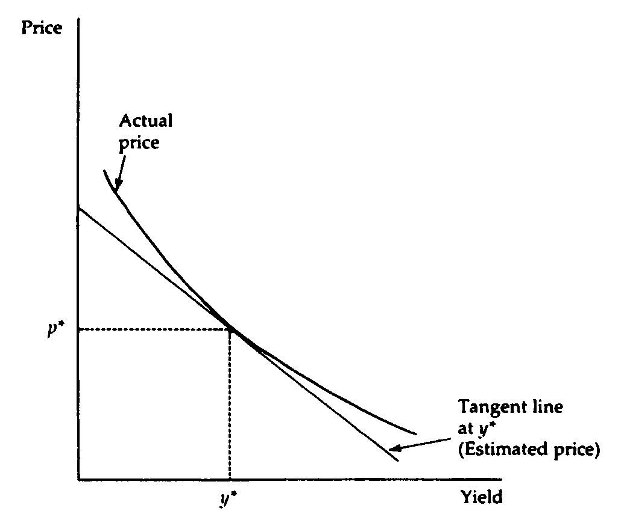
    - The estimated price that is provided by duration is on the tangent line
    - Regardless of the magnitude of the yield change, the tangent line always underestimates what the new price will be for an option-free bond because the tangent line is below the price/yield relationship
  - Rate Shocks and Duration Estimate
    - For complicated securities, small rate shocks that do not reflect the types of rate changes that may occur in the market because expected cash flows may change when dealing with bonds with embedded options
    - Large rate shocks may cause dramatic changes in the expected cash flows for bonds with embedded options that may be far different from how the expected cash flows will change for smaller rate shocks
    - If the rate shock is small and the valuation model used to obtain the prices is poor, dividing poor price estimates by a small shock in rates in the denominator will have a significant affect on the duration estimate
  - Modified Duration versus Effective Duration
    - Modified duration is the approximate percentage change in a bond’s price for a 100 basis point change in yield assuming the bond’s expected cash flows do not change when the yield changes
    - The assumption makes sense for option-free bonds such as noncallable Treasury securities
    - There are valuation models for bonds with embedded options that take into account how changes in yield affect the expected cash flows
      - Thus, when V₋ and V₊ are the values produced from these models, the resulting duration takes into account both
        - The discounting at different interest rates
        - How the expected cash flows may change
      - When duration is calculated in this manner, it is referred to as effective duration or option-adjusted duration
      - The more appropriate measure for any bond with an embedded option is effective duration
Duration
Interpretation: Generic description of the sensitivity of a bond’s price (as a % of initial price) to a change in yield

Modified Duration
Assumes that yield changes do not change the expected cash flows
Effective Duration
Recognizes that yield changes may change the expected cash flows

  - Macaulay Duration and Modified Duration
$$\text{Macaulay} \text{Duration}=\frac{\sum_{t=1}^{n}{\left(\frac{t}{k}\right){\text{PVCF}}_{t}}}{\text{PVTCF}}$$ | Where k = number of payments per year  (e.g. = 2 for semiannual  = 12 for monthly)

$$\text{Modfied} \text{Duration}=\frac{\text{Macaulay} \text{Duration}}{\left(1+\frac{\text{yield}}{k}\right)}$$

    - Modified duration is a flawed measure of a bond’s price sensitivity to interest rate changes for a bond with an embedded option and therefore so is Macaulay duration
    - The short-cut formula is better because it acknowledges that cash flows and thus value can change due to yield changes
  - Interpretations of Duration
    - Duration is the “First Derivative”
      - The “first derivative of the price/yield function” or simply the “first derivative”
    - Duration is Some Measure of Time
      - Duration has too often been thought of in temporal terms, i.e., years
    - Forget First Derivatives and Temporal Definitions
      - Duration is used as a measure of the sensitivity of a security’s price to changes in yield
      - Duration provides the investor with a feel for the dollar price exposure or the percentage price exposure to potential rate changes
  - Portfolio Duration
    - A portfolio’s duration can be obtained by calculating the weighted average of the duration of the bonds in the portfolio

w₁D₁ + w₂D₂ + w₃D₃ + … + w_{K}D_{K}

where w_{i} = MV of bond i / MV of portfolio

Di = duration of bond i

K = number of bonds in the portfolio
      - The yield on ALL the bonds in the portfolio must change by 100 bp for the duration measure to be useful
    - An alternative procedure for calculating the duration of a portfolio is to
      - Calculate the dollar price change for a given number of basis points for each security in the portfolio
      - Add up all the price changes
      - Divide the total by the initial market value of the portfolio to produce a percentage price change that can be adjusted to obtain the portfolio’s duration
- CONVEXITY
  - Convexity Measure
    - The convexity measure of a bond is approximated using the following formula

$$\text{convexity}=\frac{V_{+}+V_{−}−2V_{0}}{2(V_{0})(Δy)^{2}}$$
  - Convexity Adjustment to Percentage Price Change
    - The approximate percentage price change adjustment due to the bond’s convexity (i.e. the percentage price change not explained by duration) is

Convexity adjustment = Convexity measure x (Δy)² x 100
    - Duration combined with the convexity adjustment does a better job of estimating the sensitivity of a bond’s price change to large changes in yield
  - Scaling the Convexity Measure
    - It is possible to scale the convexity measure in any way and obtain the same convexity adjustment
Convexity Measure | Convexity Adjustment
$$\frac{V_{+}+V_{−}−2V_{0}}{(V_{0})(Δy)^{2}}$$ | (Convexity measure / 2) x (Δy)² x 100
$$\frac{V_{+}+V_{−}−2V_{0}}{2(V_{0})(Δy)^{2}(\text{100})}$$ | (Convexity measure) x (Δy)² x 10,000
$$\frac{V_{+}+V_{−}−2V_{0}}{(V_{0})(Δy)^{2}(\text{100})}$$ | (Convexity measure / 2) x (Δy)² x 10,000

  - Modified Convexity and Effective Convexity
    - Modified convexity is obtained by assuming that when the yield changes the expected cash flows do not change
    - Effective convexity is obtained by assuming that when the yield changes the expected cash flows do change
  - Illustrations of Effective Duration and Convexity

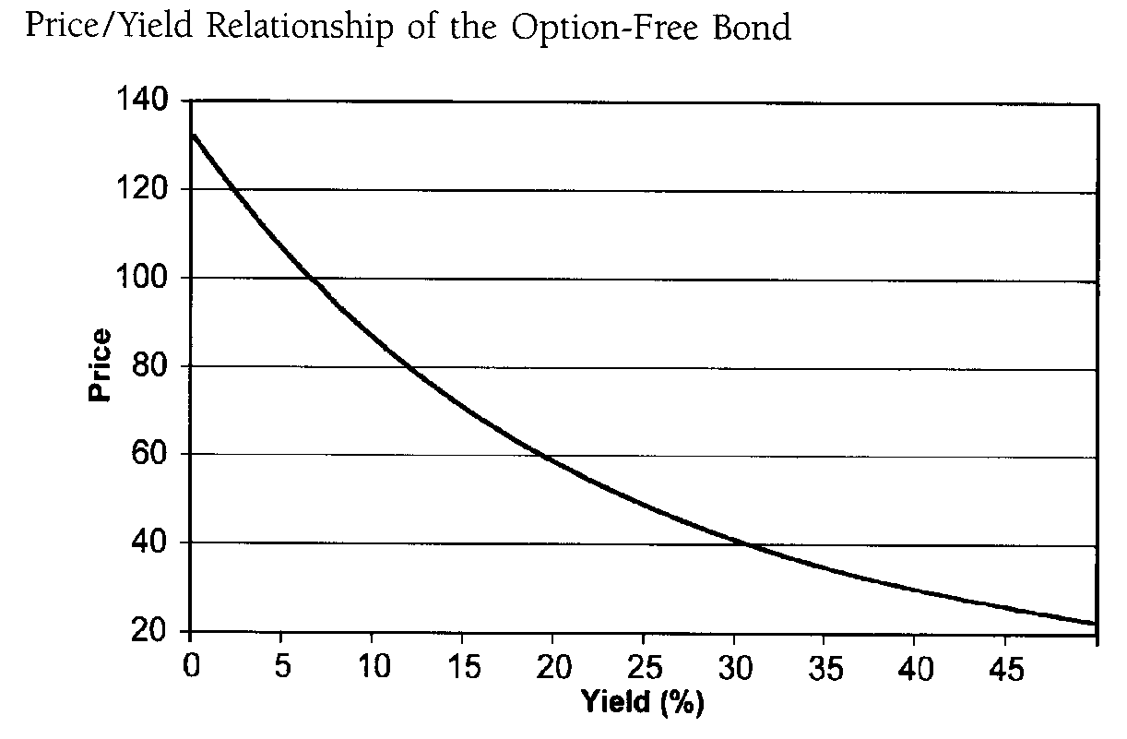

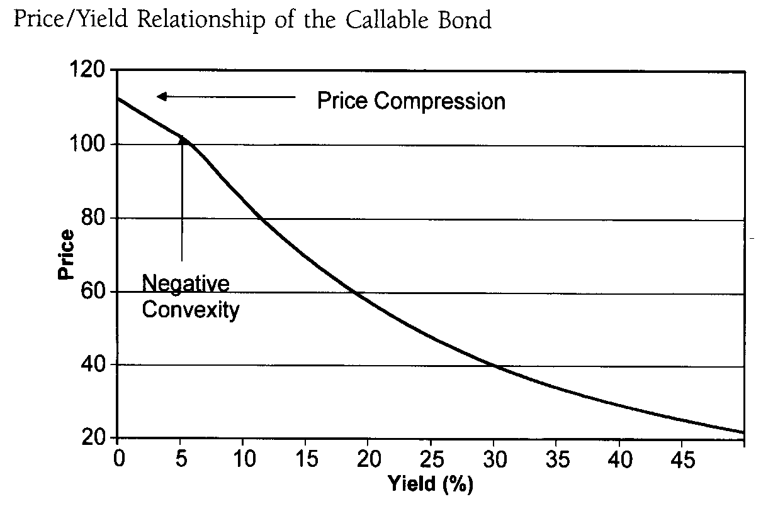

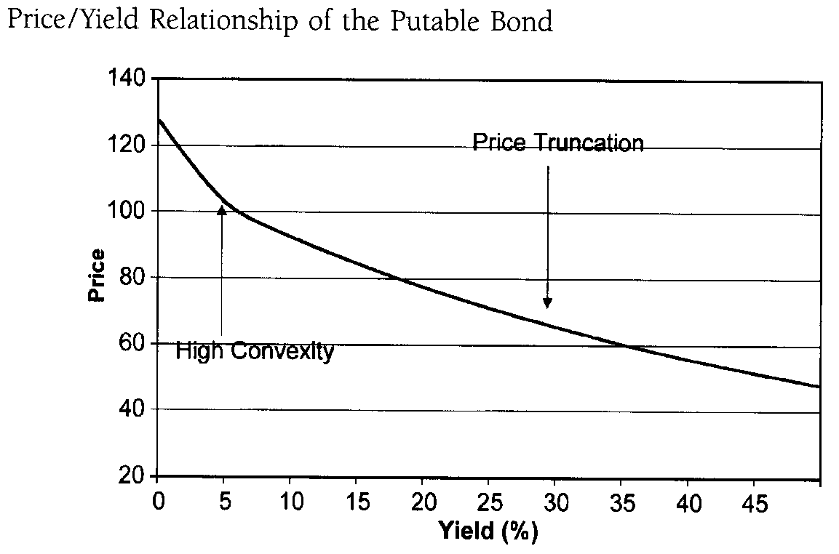
    - Price compression for a callable bond refers to the property that a callable bond’s price appreciation potential is severely limited as yields decline
    - Price truncation for a putable bond refers to the property that the putable bond’s price depreciation potential is severely limited as yields increase
- PRICE VALUE OF A BASIS POINT
  - This measure, also called the dollar value of an 01 (DV01), is the absolute value of the change in the price of a bond for a 1 basis point change in yield

PVBP = | initial price — price if yield is changed by 1 basis point |
  - It does not make a difference if the yield is increased or decreased by 1 basis point because of Property 2 — the change will be about the same for a small change in basis points
  - The PVBP is related to duration
    - PVBP is simply a special case of dollar duration
    - Given the initial price and the approximate percentage price change for 1 basis point, we can compute the change in price for a 1 basis point change in rates
- THE IMPORTANCE OF YIELD VOLATILITY
  - All other factors equal, the higher the coupon rate, the lower the price volatility of a bond to changes in interest rates
  - The higher the level of yields, the lower the price volatility of a bond to changes in interest rates
  - In terms of duration
    - The higher the coupon, the lower the duration
    - The higher the yield level, the lower the duration
  - A framework that ties together the price sensitivity of a bond position to rate changes and yield volatility is the value-at-risk (VaR) framework
    - Risk in this framework is defined as the maximum estimated loss in market value of a given position that is expected to happen with a specified probability

